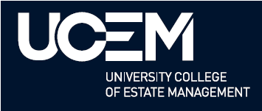
UCEM Institutional Research Repository

Title | Conceptualising an Ethno-mimetic Model for Effective Buildings’ End-of-life Waste Management: A Nigerian Exemplar
Author(s) | Aminu Lawan Abdullahi¹, Kenneth Otasowie², Angela Lee³, Bankole Osita Awuzie⁴, Clinton Aigbavboa² and Ayodeji Oke^{2,5}
ORCID
Type | Journal paper
Publication title | Business Strategy & Management  Abdullahi, A. L., Otasowie, K., Lee, A., Awuzie, B. O., Aigbavboa, C., & Oke, A. (2023). Conceptualising an ethno-mimetic model for effective buildings' end-of-life waste management: A Nigerian exemplar. Business Strategy & Development, 1–11. https://doi.org/10.1002/bsd2.241
Publisher | Wiley
ISSN/ ISBN
Publication Date | 2023
Version | This is the accepted version of journal paper.
DOI | DOI: 10.1002/bsd2.241
Repository link | https://ucem.repository.guildhe.ac.uk/
Link to publication | Conceptualising an ethno‐mimetic model for effective buildings' end‐of‐life waste management: A Nigerian exemplar - Abdullahi - Business Strategy &amp; Development - Wiley Online Library
Notes | This publication version may differ from the final version.

Copyright:
UCEM aims to make research outputs available to a broader audience via its digital Repository. Where copyright permits, full text material held in the Repository is made freely available.
URLs from GuildHE Research Repositories maybe freely distributed and linked to. Please refer to each manuscript for any further copyright restrictions.

Reuse:
Copies of full items can be used for personal research or study, educational, or not-for-profit purposes without prior permission or charge provided that the authors, title and full bibliographic details are credited, a hyperlink and/or URL is given for the original metadata page, and the content is not changed in any way.

© UCEM, 2023

Conceptualising an Ethno-mimetic Model for Effective Buildings’ End-of-life Waste Management: A Nigerian Exemplar
Aminu Lawan Abdullahi¹, Kenneth Otasowie², Angela Lee³, Bankole Osita Awuzie⁴, Clinton Aigbavboa² and Ayodeji Oke^{2,5}

¹Department of Architecture, Kano State University of Science and Technology (KUST), Kano,
Nigeria.
aabdullahi@ratelplus.com
² cidb Centre of Excellence and Sustainable Human Settlement and Construction Research Centre, Faculty of Engineering and the Built Environment, University of Johannesburg, Johannesburg, South Africa
otasowiekenneth@gmail.com, caigbavboa@uj.ac.za
³ University College of Estate Management (UCEM) , United Kingdom
a.lee@ucem.ac.uk
⁴ School of Construction Economics and Management, University of Witwatersrand, Braamfontein 2000, Johannesburg,South Africa;
obankawuzie@gmail.com
⁵ Department of Quantity Surveying, Federal University of Technology, Akure, Nigeria
aeoke@futa.edu.ng

Corresponding Author: Bankole Osita Awuzie
Postal Address: School of Construction Economics and Management, University of Witwatersrand, Braamfontein 2000, Johannesburg, South Africa.
Email: obankawuzie@gmail.com
Keywords: Ethno-mimicry . End-of-life . Buildings . Conceptual Framework . Demolition Waste. Nigeria

Abstract
In most developed nations, a formal recycling industry oversees the management of solid waste. The opposite happens to be the case in underdeveloped nations wherein, the informal recycling sector has assumed such functions. The informal methods used in Nigeria for managing buildings' end-of-life situations has shown in many ways to be compliant with the sustainability goal since they provide an excellent example of how the waste hierarchy may evolve independently, with little or no assistance from policy and regulatory bodies. The purpose of this study is to conceptualise the processes through which salvaged materials from buildings in Kano State, Nigeria is processed in a step-by-step manner, ensuring that least amounts of materials end up in a landfill. Adopting a qualitative research design to achieve the study’s aim, this study engaged nineteen purposively selected experts through semi-structured interviews in the city of Kano, Nigeria. The collected data was analysed using thematic analysis. Using the biomorphic adaptation of an African snail's shell, the study's findings led to the development of a conceptual model that depicts the actual scenario of handling demolition waste in Nigeria whilst highlighting the important elements and the inherent interactions among them. Based on these findings, the study recommends that the identified limitations in the Nigerian construction industry be addressed for the purposes of practice improvement and emergence of a comprehensive framework for the sustainable handling of building demolition waste (BDW).
Keywords: Ethno-mimicry, End-of-life, Buildings, Conceptual Model, Demolition Waste

1.0 Introduction
The sustainable management of municipal solid waste (MSW) in developing nations has been identified as an effective means of enhancing environmental sustainability, promoting social inclusion, and eradicating poverty globally (Lino and Ismail, 2012). Whilst conceding the responsibility for the management of solid waste in economically developed nations to the "formal" organised sector, scholars have ascribed this responsibility to the "informal" recycling industry in developing nations in Africa, Asia, and Latin America (Yousafzai et al., 2020; Velis, 2017; Gall et al., 2020). These informal labourers prevent developing nations from drowning in their own trash, particularly in metropolitan areas, as they act as an environmental brigade. Low labour costs, poor process standardisation, and cheap cost of technology and processes are some examples of this sector (Wilson et al., 2006). However, the central and eastern European nations coexist with the two systems (Velis et al., 2012). The "informal" participants in the system, work either as organised cooperatives or as lone actors offering door-to-door collection services and occasionally removing goods from public landfills, transfer stations, and trash bins (Medina, 2007, 2008; Kariuku et al., 2019; Nawaz et al., 2021). These unofficial participants occasionally pay taxes, have the ability, and are occasionally registered with the government.
Scholars like Kala et al. (2022), Nawaz et al. (2021) and Darbi et al. (2018) opined that, there is a growing agreement among all interested parties and experts that, in order to enhance strategies for managing waste and resources in developing countries, the informal sector generally should not and indeed cannot be neglected. Additionally, it has been claimed that these unofficial systems may employ up to 0.5% of the population, achieve a recycling rate of 20–30%, and save local governments 20% of their waste management budget because of their market-driven nature (Velis et al., 2012). However, because these systems do not work in accordance with a set convention or etiquette, they are considered "informal" because they are not authorised or recognised by the government. This is true regardless of any potential relative benefits of such systems in terms of sustainability-related metrics. Furthermore, by advancing the objectives of the circular economy, this informal sector aids in the achievement of the Sustainable Development Goals (SDGs). For instance, through the promotion of recycling, the sector helps to lessen the demand for virgin raw materials, creates jobs for the unemployed, and keeps recyclable garbage out of the landfills and the seas.
Any system with the potential to provide a solution to material waste management cannot be ignored in the current world of finite natural resources under increased pressure from the global population explosion, industrialisation efforts in developing countries, and consumerism in wealthy countries (Schandi and Miatto, 2018). Furthermore, the need for creating a conceptual model that will aid in comprehending how various variables interact to create a balanced system in Nigeria that generates almost no waste during activities associated with the construction and demolition of built assets is multiplied by the enormous impact of the built environment on resource depletion and greenhouse gas emissions (Rios et al., 2021). The conceptualisation of a model is necessitated by the novel approach of pushing the idea of biomimicry to ethnomimicry, where some activities from the non-industrialized native cultures are viewed as potential sources of inspiration for offering sustainable solutions. The purpose of this study is to conceptualise a step-by-step process and elucidate business opportunities replete in managing salvaged construction materials in Kano State, Nigeria, such that a minimum amount of such materials ends up in landfills. Additionally, this study adds to existing research on the management of building demolition waste and the function of ethno-mimicry in engendering efficient management thereof. Furthermore, the study seeks to close the conceptual gap in the literature relating to the informal approaches to buildings’ end-of-life management, using a Nigerian exemplar.

2.0 Methodology
To achieve the above, a qualitative research design was chosen. The study used a phenomenological qualitative research design. A purposive snowballing sample strategy, wherein individuals considered to be subject matter experts were approached via referrals from previously interviewed experts (Jaafar et al., 2021), was adopted. Furthermore, the number of interviewees utilized was dependent on the attainment of saturation (Fusch and Ness, 2015). According to Fusch and Ness (2015), if saturation has been reached, qualitative data is regarded as being sufficient. The study was conducted in Kano State, Nigeria, which is the second most populous state in Nigeria. Kano city is also the most populous of the second-class townships recognized by the township ordinances act of 1917 with a diverse makeup (Olukoju, 2004).
Nineteen interviewees participated in the study comprising of Architects, Quantity Surveyors, Contractors, Civil Engineers, Planers, Artisans, and Tipper Drivers in their retirement. Whereas fifteen interviewees were interviewed on an individual basis, four interviewees participated in a group interview out of their own volition. See Table 1 for the interviewee demographics.

(INSERT TABLE 1 HERE)

Although all variations in the interviewees' replies were examined, the data was also processed utilising a thematic technique template analysis. The transcribed interviews were presented as cases to the Computer Aided Qualitative Data Analysis Software (CAQDAS) QDA Miner Lite 1.4 software. Based on the main themes and sub-themes of the interviews as well as previously unidentified topics from the participants' responses, hierarchical codes were developed. The codes were arranged in groups in alignment with the major themes. After that, each case segment (transcribed interview) was given one or more codes that matched the specific information. While certain phrases and paragraphs produced new themes and codes, others were dropped due to their lack of significance. Using the software's retrieval tool, submissions by all interviewees concerning a certain topic was retrieved and presented in tabular format.

3.0 Findings, Discussion and Model Conceptualization
3.1 Identifying the Factors that Influence the Development of Practice
The identification of the constituent variables and subsequent establishment of their interrelationships are the initial steps in the construction of a conceptual model (Awuzie and McDermott, 2019). These variables were extracted from the interviewees who detailed various facets for managing buildings after the end of their useful lives in Nigeria.
3.1.1 The Beneficial Factors
3.1.1.1 The Process of Building Demolition
According to the interviewees’ comments, there are no widely accepted standard techniques for decommissioning building structures which can be considered as typically relevant in all circumstances. The only thing that all the methods mentioned have in common is the sequence in which detachable components like the roof, windows, plumbing, and electrical fixtures are removed before the building's main structure is demolished (P1; P5; P6). Interviewees agree that the building's skeleton is always taken off from top to bottom apparently for safety reasons. One technique entails the removal of all movable things, the removal of the roof, ceiling, electrical installations, doors, and windows, and the subsequent flattening of the building structure, commencing from the roof to the base (P1; P2).
An interviewee described the stages of decommissioning and gave a particular scenario - “So we took physical measurement of what is on site, and designed an alternative structure and used (retained) part of the walls (existing) and erect some new ones (walls). We did not start demolishing immediately until after the foundation of the new walls was dug, and the walls erected up to the floor level in order to save cost. Then instead of buying laterite for filling to make up levels, we demolished the unwanted walls and used the rubbles for filling to make up levels, and that saved us a lot of costs” (P4).
The building is deconstructed in a way that maximises the possibility of salvaging the materials for re-use or sale. This is the sustainable element that unites all descriptions of the process for demolishing buildings. The ability to creatively use the materials on the same site for a new structure that replaces the old has been shown in some instances. Another sustainable strategy for reducing waste lies in the extension of the material lifespan (Ludeke-Freund et al., 2018).
3.1.1.2 Materials Sorting and Handling
One of the interviewees provided detailed information on material sorting, demonstrating that items are organised according to their usage and handling requirements. “The materials were sorted according to its usefulness and handling requirements. Thus, materials are handled in different ways. Zinc roofing sheets for example are handled in a different way than asbestos, which breaks easily. Reinforced concrete elements are handle in two stages; after the concrete element is brought down, it is further broken down using smaller hammers to remove the reinforcement bars for onward sales to the salvaged products marketers. Damaged ceiling boards that cannot be reused for any purpose usually end-up in a landfill. The broken rubbles are sold at a cost, sometimes N 45, 000 per trip. Actually, very few items may be taken to the refuse dump; even the ceiling boards were taken to the refuse dump because it was damaged by rainfall. Otherwise, it should have been marketable as it is useable for other purposes. Like the aluminum roofing sheets that are used for making cooking pots” (P1).
Many artisans who work on building construction projects are typically hired to take down the parts that pertain to their areas of expertise. Adopting this approach, a carpenter will take down the roof, a plumber will take down the plumbing fixtures, and an electrician will take down the electrical systems.
Public, private establishments and demolition contractors organise recovered objects with care and give to a permanent committee for asset disposal through auctioning (P2; P8; P9; P11; P12). However, clearing the site is frequently left to a government body in charge of waste disposal (P14; P16).
3.1.1.3 Economic Factors
The interviewees, in more than half of the examples posted, opined that the state of the national economy had a significant impact on how buildings’ end-of-life management was carried out in Nigeria. Even though some participants mentioned the state of the economy in passing, there was a startling repetition of phrases used by the interviewees to refer to the economy, such as "Of course the economy," "the more affluent the people are, the more they want bigger things," and "the more they want luxury." There will be more decommissioning if the economy is strong. Another interviewee made a similar sentiment, noting that individuals purchased secondhand goods because the national economy was struggling. On the other side, more personnel will be required to demolish buildings if the economy was doing well (P3; P7; P8; P9 and P6). P16 posited “if the economy is doing well, we have more decommissioning taking place. Like what I noticed in 2010, I had more decommissioning than any other year. When the economy is booming people will want a change in service”
Nevertheless, these remarks convey contradictory meanings. In the first section, it is implied that individuals may not need to employ salvaged materials when the economy is doing well, whereas in the second section, it is said that more people will decommission building when the economy is doing well. However, the two may be balanced since as more people get wealthy, an increased need to demolish houses for renovations or a change in use can be discerned. On the other side, less individuals would be interested in buying salvaged materials instead of new ones if the socioeconomic status of the citizens reduces the divide between the affluent and the poor. At this point, it is crucial to discuss Nigeria's socioeconomic structure, which is polarized, with a super-rich top class, an extremely impoverished bottom class, and essentially no middle class (Aiyedogbon and Ohwofasa, 2012). Because of this, when the wealthy demolish, the lower class rebuilds using the salvaged materials, resulting in a balanced system that prevents the environment from being polluted.
Also, unemployment was mentioned by the interviewees as a reason for the development of this profession. In this instance, the technique protects the environment by recycling resources and also generates employment. “Before, twenty years back it does not happen like this; I think the economy is really changing things. People are now looking for anyway. I can get employed, I can now do that. Before it was done at a very lower level; you can hardly see anybody breaking concrete and taking rods; no! But now it is the fastest thing to be done. I think in those days some of the things you look at was the roofing sheets and timber; and may be doors and windows” (P14).
In a different situation, some interviewees said that financial difficulties prompted the birth of their business. They also provided information on how it is more lucrative to make their goods with recycled resources than using fresh ones. Others who took part in the discussion merely called the behavior "normal." “Natural! It is just normal. When you take something away and someone needs to reuse it, he will either come and demand it or make a purchase. It simply develops naturally!” When supply and demand co-exist, that is all there is to it. In the same vein, some have compared the practice to nature, saying that what one individual may not find beneficial for himself or herself, others may find valuable. This is how it functions. Some of the interviewees attempted to describe the interactions between creatures in the food chains of natural ecosystems, where there is no waste. What one organism would deem undesirable (waste) stuff provides sustenance (raw material) for another. The idea of industrial ecology was motivated by this idea in the natural ecological system (industrial symbiosis) (Domenech et al., 2019, Baldassarre et al., 2019).
3.1.1.4 Belief and Cultural Factors
Culture and belief were identified by five out of the sixteen interviewees, or 31% of the total, as additional elements that affect the prevalence of the reuse of salvaged construction materials in Nigerian society (P3; P7; P13; P14; P16). One interviewee said, “this depends upon the culture and level of development of any community. Here in Kano, in Kurmi market you see a shop built in 1904 alongside another shop that was decommissioned and rebuilt probably this year…” (P13). One can infer that these individuals are alluding to the ancient Hausa tradition and practices that Schwerdtfeger documented (1982, pp. 58, 87-88). This ancient custom calls for burying the deceased in or near their chamber and letting the structure crumble gradually over time. The following generation re-uses the mud and the space from the fallen construction to make bricks and reconstruct another chamber, while the roof's timbers are utilised for a new building or as firewood. This tradition may have unintentionally affected the prevalence of recycling culture as applied to building materials as practiced by the current Hausa population of Kano, alongside other considerations. Additionally, the Hausa people are well known for their conservative outlook in a variety of contexts (Adamu, 2006; Whitsitt, 2003).
This culture supports the widespread use of salvaged building materials in yet another structure or for other purposes other than those necessarily related to the construction industry in the context of managing demolition waste. A waste from one building becomes a raw material for use in another building or other sectors, eliminating any waste, in a manner similar to the natural ecological systems. Practically speaking, this amounts to industrial symbiosis. According to the waste hierarchy concept and the EU waste management guideline, reuse of materials is also regarded as the second most sustainable waste management method (DOE, 2012; Kibert, 2016; Nowak et al., 2009).
Contrarily, another factor that adds to the practice's widespread use is the extant belief system. Argumentum ad antiquitatem, or appealing to antiquity, is a habit among the Hausa people. The Hausas had the view that an object's quality increased with age. Whereas this idea may be considered a fallacy, yet it supports the custom of utilising salvaged construction materials over and again while also giving the materials a higher worth. One of the interviewees, who has thirty (30) years of experience as an architect and a government servant, stated the following: “the older the material is, the more probability that, it will be of higher quality. You will realise that the most recent materials are even destroyed in the process of decommissioning; therefore, they are less valuable” (P13). He continued by adding the following details to his earlier point:
“That is what I said- if what the stakeholder wants is aesthetics, then definitely newer materials from decommissioning may be valuable, but where quality is considered, the older ones are better. It is logical that if a building material can last for fifty years in a building and is still in good condition, it means the quality is tested and trusted. There is a probability that it will last for more years. Even the manufacturer of that components will enjoy preference for even the new materials he is making now; his products have been tested and even among the newer products now, his own will be more valuable. He has established goodwill with the public- his product has been tested and trusted” (P14). He was not the only interviewee who had this opinion; others did as well.
The causes for this philosophy's popularity may be outside the purview of this article, yet this philosophy is supportive of environmental sustainability thinking. It is in opposition to the philosophy of “argumentum ad novitatem” common among the societies of the industrialized nations, which supports the unsustainable fashion and trend mentality, where a seasonal cyclical phenomenon is quickly accepted and abandoned (Bhardwaj and Fairhurst, 2010).
3.1.1.5 Stakeholder Roles
3.1.1.5.1 Professional Advice
Six interviewees testified that professionals have a big influence on how buildings are handled at the end of their useful lives. In one instance, the project manager and architect in charge described how the client asked him and his team to advise on how to best tear down the building, how to dispose of the salvaged materials, and whether some of the salvaged materials could be used in the new building. Another time, in a university, the management and a committee solely took expert counsel into account when making decisions, which occasionally included whether to destroy or not (P11; P8; P12; P4; P5; P7).
3.1.1.5.2 Government Activities
According to some of the participants, there was a correlation between the activities of the government demolition and an increase in those activities, primarily as a result of improvements to public buildings, the removal of non-compliant structures, and the provision of infrastructure (P2; P7). Government demolition operations open up chances for various parties involved in the trading of salvaged materials; this sector is solely dependent on the number of demolition projects. According to another group of participants, the activity originated as a popular protest to the building deconstruction actions of the government. It was suggested that there was a connection between the government's frequent upgrades of public facilities, which occasionally involved entire decommissioning of buildings, and the operations of the market for salvaged goods (P13; P14).
3.1.1.5.3 Specialist Stakeholders
In processing the recovered materials that result from the procedure outlined in the preceding section, various stakeholders have varied responsibilities. The choice to decommission the structures is made by the clients or building owners. While contractors are hired to carry out the actual physical deconstruction of the structures, professionals like architects, engineers, quantity surveyors, and others are contracted to provide services related to their field of study. Contrarily, according to the interviewees, there are craftsmen and assistants who are employed by the contractors and occasionally directly by the client to work in the many aspects of the building demolition (P12).
Another group of stakeholders are the marketers, who act as middlemen, buying the various rescued components to resell to the end-users who could reuse them in another building or for other uses. Most of the interviewees' accounts served as the foundation for this definition of the stakeholders' overall function. However, another group of specialised stakeholders that play various functions and are crucial to the operation of the building demolition business are also present, and their unique function is explained below.
In three separate positions, the group of "expert stakeholders," known as "Yangwangwan” in the local Hausa language, directs the activities of the recovered construction materials. The first group of "Yangwangwan" are traders who buy and sell salvaged goods at the well-known local marketplaces for salvaged materials, which are dispersed across the Kano city. The Kingsway market at Murtala Mohammed Way in Sabon-gari Township is the biggest and maybe the most well-known of these marketplaces, which are similarly specialised in salvaged materials. There are more markets on France Road, in Tarauni, Kofar Ruwa, and Sharada. However, these marketplaces have similarly big stockpiles of the product. There are numerous smaller salvaged materials markets scattered across the city of Kano metropolis, thus even though these markets may be the most well-known, the list is not exhaustive (P1; P4; P14).
The second type of "Yangwangwan," who called themselves tinkers, reprocess the salvaged materials into diverse goods before it is resold in the market. The first category of the "Yangwangwan" are essentially dealers who purchase and sell the salvaged materials. Cooking pots, kerosene stoves, coal stoves, bread molds, chicken feeders, and a freezer are a few of these things (P7).
The third group of "Yangwangwan" is made up of independent scavengers who may get access to a demolition site to salvage as much valuable material as possible, including cracking concrete components in order to recover the reinforcements. Since this is a relatively new phenomenon, their actions may be driven by unemployment and poverty, and they occasionally entail a lot of unlawful activity, as in the accounts provided by some of the interviewees (P2; P14).
The three types of "Yangwangwan" do not clearly distinguish themselves as merchants, tinkers, or scavengers, as several interviewees noted; the traders and tinkers may also work as contractors, while the scavengers may operate as traders depending on the chance. The three different categories of "yangwangwan" all specialize as full-time professionals who rely on the materials recovered during building deconstruction for their livelihood, which is what unites them. The almost complete absence of demolition waste in society at large may be a contributing factor in this group's operations.
The government is listed as the owner of the programs to demolish public buildings and unlawful structures, even though none of the participants reported on the actions of external stakeholders like non-governmental organizations (NGOs). This implies that the government does not regulate or participate as an external stakeholder in the demolition industry. Most of the interviewees concur that the original content producers have little bearing. However, it was said that the companies that roll steel and smelt aluminum buy scrap from the "yangwangwan" to recycle into reinforcement.
On the other side, the negative elements are divided into two categories: inadequate industrial organisation and workplace health and safety.

3.1.2 The Harmful Factors
3.1.2.1 The Occupational Health and Safety
The situation reports on occupational health and safety (OHS) in building demolition projects in Nigeria, as stated by Idoro (2008), is not significantly different from that of the overall Nigerian construction sector, according to the accounts of some of the participants. Compliance with OHS standards during demolition activities in Kano was deemed a challenge by a merchant of salvaged items who also occasionally works as a contractor. The workforce is untrained and careless when it comes to OHS. Although he only identified one instance, he thinks there may be many more deaths related to demolition activities, most of which are the result of unreported and unrecorded falls from heights. Others in the discussion agreed, saying that for Nigerians, who prioritize financial gain over everything else, the OHS in demolition is the last thing on their minds. Some individuals hold the opinion that OHS safeguards might only be necessary while working with multi-storey structures. Nigerians have tendency to take so many things for granted, including OHS compliance. As such, there does not seem to be any concerted effort towards sustaining compliance as everyone is allowed to manage on their own.
An interviewee who has played several roles in the Nigerian construction sector provided the following story, which bothers on the extreme: “There is not much consideration given to health and safety in our construction field. There is a story of a project where I manage the funds, and I paid for the emergency medical treatment of an accident victim on the site. Unfortunately, the client was furious and strongly objected about such action. There are examples of constructions where the contractors completely ignore health and safety issues completely despite a budgetary provision in the contract for that purpose. When the Government is alerted on such issues, an action will definitely be taken” (P2).
On the other hand, there were reports of successful attempts to implement some OHS measures during demolition activities. Some interviewees mentioned using hand gloves, facial masks, helmets, and safety boots, as well as proactive sensitization of neighbours who could be impacted by the deconstruction. According to reports, the members of the demolition team contracted by the development control authority wear helmets, boots, jackets, and whistles and have a medical team on standby. Both the provision of first aid kits and proactive communication with the neighborhood hospital were recorded.
However, none of the interviewees were able to name a specific piece of legislation regarding OHS during building deconstruction. Many others replied with "I'm not aware," "not aware," or just "No." (P1; P4; P5; P6; P10; P11; P14). As a group, four interviewees said that the government had no regulatory function in their field. Despite this, there were some hints that the government would be making an attempt to control demolition operations, which might involve OHS. A participant described how he, an environmental officer, approached to inquire whether the demolition activity had received clearance. He displayed a KNUPDA endorsement (Kano Urban Planning and Development Authority). He was informed that further authorisation from their office was required in order to demolish, and that was the last he ever saw of them. Another interviewee speculated that one of the neighboring states may be working on legislation related to occupational health and safety (administrative regions) (P3).

3.1.2.2 Lack of an Improved Industry Organisation
According to two interviewees, manual labour is sometimes used in Nigeria to demolish structures because there is no other option, or it is simply too expensive to utilize other methods. The biggest problem is a shortage of equipment. It is so rare and expensive to rent when it available, which is what is happening in Kano. As a result, a decision is usually taken to employ manual labor (human power) to complete the operation (P15; P16). The building business, including demolition businesses, seems to have a thirst for better technologies. However, even while using machinery for demolishing, it is likely to cause pollution and fossil fuel use which is again, harmful to the environmental sustainability paradigm. On the other hand, the need to remove materials in a useable state may justify using hand tools rather than large machinery. A situation where hand tools were used instead of heavy equipment to minimise material damage has been documented.
According to an interviewee, there have been examples of improper handling of items rescued following demolition, particularly in projects involving the public. There was a story of a similarly riskier encounter on another project involving the conversion of a police barracks into a general hospital. In a free-for-all race for the recovered materials, the people took control of the decommissioning process. This incident serves as a reminder of the necessity to create a framework for the efficient administration of the procedure for transferring salvaged goods, particularly in light of the potential for additional issues like conflicts with security personnel.
Marketers of salvaged goods claimed that the police had harassed them on the grounds that they could have been acquired illegally. As was already said, the salvaged goods business occasionally has a bad reputation due to criminal actors' actions in one way or another.
Every time a public building is demolished, the social atmosphere, in the words of one interviewee, may be difficult; "you encounter obstacles from the neighbouring individuals," the interviewee (P12) remarked. This could entail stealing and disturbances brought on by rivalry over who gets to keep the salvaged building components. Another interviewee said that when a building is demolished by the government, it results in changes, and people are naturally resistant to change, especially when their personal property is at stake. It was suggested that communication with the neighborhood becomes essential when public facilities are decommissioned, especially when there is a shift in function (P2; P13).
In one instance, debris from a demolished building was needed for reuse in the proposed new building. However, the lack of storage space resulted in objections from nearby residents, thus the debris had to be carted away and repurchased at a later stage of the project. An interviewee referred to these situations as obstacles and remarked, "...you know, you need a storage for other products too" (P11).
Building demolition is a frenetic operation that needs experienced and committed supervision, especially when salvageable materials may need to be removed. This was seen as just another obstacle for the sector. Building deconstruction was often thought of as a free-for-all, unregulated enterprise requiring a prompt reaction. This might take the shape of rules to direct the actions of the specialists engaged or guidelines on how to handle the leftovers from demolition efforts. The next part will go over several strategies for enhancing the business operations of the sector (P4; P15).

3.2 Interrelationships existing between the Factors
Figure 1 highlights the extant interrelationships between the factors articulated in the preceding section.
(INSERT FIGURE 1 HERE)
It was stated that economic incentives are the primary factor affecting waste management practices in the less economically advanced nations, whereas the law drives waste management systems in the economically developed countries (Schneider and Ragossnig, 2014). Even while it is thought that the waste regulation in economically developed nations is motivated by sustainability concerns, it might also be tied to economic factors. This is because the idea of sustainability has its origins in economics, particularly when considering the linguistic origin and definition of economy as "the careful management of existing resources" (Oxford Dictionary, 2016). The sustainability tenets are also the driving force behind waste management laws in industrialised nations. Therefore, it can be said that waste management techniques come directly or indirectly from economic factors in both developed and developing nations.
The preceding part covered the circumstances that foster the creation of the economic incentives that direct a waste management system, such as the phenomena of this research, in the absence of regulation. This section explains how various elements work together and overlap to generate the desired result. This is a reference to the interaction of both advantageous and detrimental elements to produce the economic incentive that supports the salvaged building materials sector in Nigeria. The processing of the recovered materials benefits all parties involved, but specialists "Yangwangwan" in particular, in some way. The reduced cost of buying the salvaged items in comparison to the alternative new building materials is the economic motivation for the end customers. While the economic advantage to the disposer comes from the revenue generated by the resale of the salvaged goods. Members of the supply chain benefit from acting as middlemen who buy resources at a cost and resell them to potential customers at a profit. The payment they receive and the chance to serve as resale agents attracts both the employees and the "foragers" in equal measure. Other facets of the phenomena include the market and technology for enhancing salvaged materials and converting them into some other items. The government benefits from the employment produced for the populace and the possible tax revenue. Figure 2 highlights the interplay between the conditional variables, the economic incentives and limitations influencing participation within the Kano building demolition ecosystem as gleaned from the perspectives of the interviewees.
(INSERT FIGURE 2 HERE)
Unsurprisingly, the rescued materials are managed in a manner that is more distinctive than the EU waste hierarchy. According to the waste hierarchy, reusing, recycling, utilising the waste as fuel to recover energy, and eventually depositing the garbage in a landfill are the most sustainable and optimal ways to manage waste in hierarchical order. According to the research interviewees, all elements from a decommissioned building are rescued for re-use in some fashion, perhaps not exactly in the same way as in its original use, even if the lifespan of the structure is extended as much as possible to prevent producing wastes.
Re-using materials may be done in three different ways: recycling, upcycling, and downcycling (Sassi, 2008). When a material is used in a similar way to how it was used in a decommissioned structure, it is just being reused or having its lifetime extended; when it is upgraded to be used in a more major way, it is being "up-used" and when it is used in a less significant way, it is being "down-used" A good example is the aluminum roofing sheet, which may be used again for roofing, upgraded to become a door or a barrier, or downgraded to become smaller items like pots or a mould.
From the accounts of the interviewees, it can be assumed that all salvaged materials are screened to ensure that only materials that cannot be reused in any other way at all are allowed to pass to the recycling phase of the process, similar to the hard gate 1 from the Process Protocol (a model developed in the UK that aimed to provide a generic process that encompasses best practice for the entire design and construction sector). See Lee (2002) for more on the Process Protocol model.
There is another filter, known as the hard gate 2, that sieves the material to make sure that only materials that could not be recycled pass to the next stage for energy recovery, even if only materials that could not be utilized are evaluated for recycling. For energy recovery, materials that couldn't be recycled or repurposed are taken into consideration. After going through a second screening at hard gate 3, if the material could not be utilised as fuel, it could have to be unavoidably placed in the landfill. In this procedure, most of the rescued materials were used again, while just a tiny fraction of the materials was recycled, a much smaller portion were used as fuel, and barely any were dumped in landfills. The Process Protocol's idea of a "hard gate" refers to a firm decision made before moving on to a process's next stage (Aouad et al., 1998). An illustration of this process is shown in Figure 3. It shows how the materials are treated such that only a little amount ends up in the landfill.
(INSERT FIGURE 3 HERE)

An investigation of the municipal solid waste performed by Nabegu (2008, 2010) provided more evidence of this process. According to the Gordon guide for data collecting in cities, samples of municipal solid waste were taken from landfills in three distinct residential districts of Kano during a three-month period for one of these studies. The samples were then divided into groups for study. In the second research, secondary information was gathered from Kano State Refuse Management and Sanitation Board, the sole government body in charge of managing municipal solid waste (REMASAB). In these studies, solid wastes were divided into several categories, including biodegradable material, industrial waste, non-biodegradable material, including certain glassware and metals, and others (Nabegu, 2008, 2010). But there was absolutely no discussion of demolition waste. The tiny glass and metal fragments are presumably from everyday goods like bottles and cans, and a very small amount is probably from building deconstruction. In this town, demolition waste is not viewed as garbage but rather as a commercial commodity with a reasonably developed market and stakeholders. Indeed, reusable building demolition byproduct handling is a separate economic sector with several participants.

3.2.1 A Concept for the Model
The biomorphic structure of an African land snail was used as a conceptual model to depict the aforementioned procedure. While Biomorphism is the imitation of naturally occurring physical structures without necessarily sharing any functional principles, Biomimicry refers to the discovery of sustainable solutions to human issues by adopting biological principles from nature (Pawlyn, 2011). The processes in buildings’ end-of-life management can be explained by comparing their physical structure to that of the giant African snail's shell. See Figure 4. Each of the segments that make up the protective coiled structure of the snail shell may be seen as a step in the broader process of managing recovered materials.
(INSERT FIGURE 4 HERE)

The snail's head may be seen above the shell when it is not retracted, but a typical shell is made up of segments that are disproportionally large and organised in descending order to resemble a funnel. The first segment, which is the biggest, makes up between 50 and 60 percent of the shell's total size, and the second segment, which makes up around 20 percent, come next. The third and fourth parts each fall between 8% and 15%. The fifth and sixth segments make up around 1–5% of the whole shell's size, however they are significantly smaller. Each of these segments is twisted to produce a spiral that connects to the following segment to make a larger, more complete spiral.
(INSERT FIGURE 5 HERE)
Figure 5 details how components of the African snail's shell may be used to symbolise the processing of materials towards the end of a building's useful life in Nigeria, a country with a near-zero demolition waste generation.
As the building structure is being disassembled, the action begins with the removal of materials. Similar to how a snail retracts its head and body into its shell for safety when faced with danger, the materials are often withdrawn with the reuse goal as a sanctuary for the materials rather than depositing them in a landfill. The first and larger segment of the snail shell can be interpreted as representing the reuse of salvaged materials, which is the biggest and most significant technique used in materials handling and is represented in the first and largest segment of the snail shell when the salvaged materials are retracted into the protection of the "shell". According to the research participants' descriptions, most materials—possibly as much as 50–60%, or the percentage of the first section of the snail shell—are recycled. By going through a conceptual filter or hard gate that ensures only qualifying materials move on to the next phase, materials that cannot in any way be reused for the same purpose or for a different purpose will be evaluated for feasibility for recycling. The second and third shell segments can be thought of as representing the recycling process, and it is advised that all recycled materials not exceed 20%, which corresponds to the proportion of the respective shell segments. After passing through another fictitious filter, additional materials that don't fit any of the requirements from the earlier stages can be considered for use as fuel, although it's advised that their percentage should not exceed 10% to match that of the fourth shell segment. When compared to the proportion of the fifth segment of the snail's shell, the fifth segment that is disposed of in a landfill should not be more than 5%. However, as this study does not involve quantitative measurements, it should be highlighted that the numerical percentages are merely suggestions motivated by the distribution of the segments in the snail shell.
The factors that contribute to the practice's success and their interactions, as stated above, are represented in the upper portion of the model, which corresponds to the snail's head.
4.0 Conclusions, Implication and Recommendation
This study demonstrated that, while the management of solid waste is carried out by what might be referred to as an organised "formal" sector in economically developed nations, the informal recycling sector has received the credit for being largely responsible for the solid waste management in developing nations. It is crucial not to ignore this industry since it has the potential to generate revenue for the government, employ 0.5% of the population, reach a recycling rate of 20–30%, and help local governments save 20% of their waste management budgets because of its market-driven nature. Furthermore, this informal recycling sector helps the construction industry clients to save money by reducing demolition waste disposal cost, while increasing efficiency in resource use in developing nations. Also, the sector helps to enhance reputation, comply with regulations, and foster innovation in construction firms in the management of construction demolition waste.
By supporting and adopting the identified practices in this study, construction sector can not only reduce their environmental impact but also improve the bottom line of firms within the sector, while contributing to sustainable development and creating new business opportunities and providing jobs for the unemployed. The same has been claimed of informal methods used in Nigeria for managing buildings towards the end of their useful lives. This makes it important to research and learn from this sector's understanding on how to live sustainably and in harmony with the environment, since it develops organically with little governmental or regulatory interference.
The construction of a conceptual model is further necessitated by the novel approach of pushing the idea of biomimicry to ethnomimicry, where some activities from the non-industrial cultures are viewed as potential sources of inspiration for offering sustainable solutions. As a result, a conceptual model was created to illustrate the major elements and how they interacted in the real-world scenario of processing demolition waste in Nigeria. This model was created using a biomorphic modification of an African snail's shell and the model can help facilitate the development of new business models within the construction sector. These business models could involve up-cycling, which is the process of transforming construction demolition waste materials into a new product of higher value, or down-cycling, a process of transforming construction demolition waste materials into a new product of lower value.
The study makes recommendations based on its findings on how to improve the industry's practices and create a comprehensive business framework for the sustainable management of demolition waste. These recommendations are based on the limitations that the study found in Nigeria's construction sector which has been chronicled in the preceding parts of the paper.

References
Adamu. (2006). Loud bubbles from a silent brook: Trends and tendencies in contemporary Hausa prose writing. Research in African literatures, 37(3), 133.
Aiyedogbon, J. O., and Ohwofasa, B. O. (2012). Poverty and youth Unemployment in Nigeria, 1987-2011. International Journal of Business and Social Science, 3(20), 269-279.
Akeju, A. A. (2007). Challenges to providing affordable housing in Nigeria. Paper presented at the Proceedings of 2nd Emerging Urban Africa International Conference on Housing Finance in Nigeria.
Aouad, G., Hinks, J., Cooper, R., Sheat, D., Kagioglou, M., and Sexton, M. (1998). Map for a generic design and construction process protocol. Journal of Construction Procurement.
Awuzie, B.O. and McDermott, P., 2019. Infrastructure delivery systems: Governance and implementation issues. Cham. Springer. pp 188
Baldassarre, B., Schepers, M., Bocken, N., Cuppen, E., Korevaar, G. and Calabretta, G., 2019. Industrial Symbiosis: towards a design process for eco-industrial clusters by integrating Circular Economy and Industrial Ecology perspectives. Journal of cleaner production, 216, pp.446-460.
Darbi, W., Hall, C. and Knott, P. (2018). A Review and Agenda for Management Research. International Journal of Management Review. 20, 301-324
De Soto, H. (2000). The mystery of capital: Why capitalism triumphs in the West and fails everywhere else: Basic books.
Domenech, T., Bleischwitz, R., Doranova, A., Panayotopoulos, D. and Roman, L., 2019. Mapping Industrial Symbiosis Development in Europe_ typologies of networks, characteristics, performance and contribution to the Circular Economy. Resources, conservation and recycling, 141, pp.76-98.
DOE, D. o. t. E. (2012a). Waste Management: The Duty of Care- a code of Practice for Northern Ireland. Northern Ireland: Deparrtment of the Environment Retrieved from http://www.doeni.gov.uk/waste_management_duty_of_care_code_of_practice_for_ni.pdf
Fusch, P. I., and Ness, L. R. (2015). Are We There Yet? Data Saturation in Qualitative Research.The Qualitative Report, 20(9), 1408-1416. Retrieved fromhttp://nsuworks.nova.edu/tqr/vol20/iss9/3
Gall, M., Wiener, M., de Oliveira, C. C., Lang, R. W., & Hansen, E. G. (2020). Building a circular plastics economy with informal waste pickers: Recyclate quality, business model, and societal impacts. Resources, Conservation and Recycling, 156, 104685.
Geert, H., and Jan, H. G. (1991). Cultures and organizations: Software of the mind. McGraw-Hill, New York.
Goodland, R., and Daly, H. (1996). Environmental Sustainability: Universal and Non-Negotiable. Ecological Applications, Vol. 6(4), 1002-1017
Idoro, G. I. (2008). Health and safety management efforts as correlates of performance in the Nigerian construction industry. Journal of Civil Engineering and Management, 14(4), 277-285. doi:10.3846/1392-3730.2008.14.27
Jaafar, M., Salim, A.A.N., Salleh, M.N., Sulieman, B.Z., Ulang, M.N. and Ebekozien, A. (2021), “Developing a framework for fire safety management plan: the case of Malaysia’s public hospital buildings”, International Journal of Building Pathology and Adaptation. doi: 10.1108/ IJBPA-04-2021-0060.
Kala, K., Bolia, N. and Sushi. (2022). Analysis of Informal Waste Management using System Dynamic Modelling. Heliyon. 8(8), e09993
Kalejaiye, P. O. (2013). Occupational health and safety: Issues, challenges and compensation in Nigeria. Peak: Journal of Public Health and Management, 1(2), 16-23.
Kariuki, J. M., Bates, M., & Magana, A. (2019). Characteristics of waste pickers in Nakuru and Thika municipal dumpsites in Kenya. CJAST, 37, 1-11.
Kibert, C. J. (2016) Sustainable Construction: Green Building Design and Delivery, 4th ed. New York: Wiley.
Lee, A. (2002). The development of a project process evaluation (PPE) framework that aims to measure the effectiveness of implementing a new design and construction project process. (PhD), University of Salford, Salford, UK.
Lino, F. A. M., and Ismail, K. A. R. (2012). Analysis of the potential of municipal solid waste in Brazil. Environmental Development, 4, 105-113.
Ludeke-Freund, F., Gold, S. and Bocken, N. (2018) A Review and Typology of Circular Economy Business Model Patterns. Journal of Industrial Ecology. 23(1), pp 36-61
Medina, M. (2007). Waste picker cooperatives in developing countries. In Membership based organizations of the poor (pp. 125-141). Routledge.
Medina, M. (2008). The informal recycling sector in developing countries: organizing waste pickers to enhance their impact.
Nabegu, A. B. (2008). Municipal Solid Waste Characteristics in three Residential Zones of Kano Metropolis: Implications for Management. Paper presented at the Geography and the MillenniumDevelopment Goals: Translating Vision into Reality in Nigeria. Association Geographers Conference Book of proceedings, Calabar, Index Books Publishers Ltd.
Nabegu, A. B. (2010). An analysis of municipal solid waste in Kano metropolis, Nigeria. Journal of Human Ecology, 31(2), 111-119.
National Occupational Safety and Health Information Centre. (2006). Nigeria: Report of the National Occupational Safety and Health Information Centre, . Retrieved from Geneva, Switzerland: http://www.ilo.org/legacy/english/protection/safework/cis/about/mtg2006/pnga_mlpid.pdf
Nawaz, M., Yousafzai, M., Khan, S., Ahmad, W., Salman, M., Han, H., Ariza-Montes, A., and Vega-Munoz, A. (2021) Assessing the Formal and Informal Waste Recycling Business Processes Through a Stakeholders Lens in Pakistan. Sustainability, 13, 11717.
Nowak, P. O., Steiner, M., & Wiegel, U. (2009). Waste Management Challenges for the Construction Industry. Construction Information Quarterly, 11(1), 5-11.
Ogunshakin, L., and Olayiwola, L. (1992). The collapse of official housing policy in Nigeria. Habitat International, 16(1), 41-53.
Olukoju, A. (2004). Nigerian cities in historical perspective. Nigerian Cities, 11-46
Oxford Dictionaries. (Ed.) (2016) Oxford Dictionaries Language Matters. Oxford University Press.
Rios, C., Grau, D., Bilec, M. (2021) Barriers and enablers to circular building design in the US: An empirical study. Journal of Construction Engineering and Management, 147 (10) 10.1061/(ASCE)CO.1943-7862.0002109
Robinson, S. (2015) A Tutorial on Conceptual Modeling for Simulation. Proceedings of the 2015 Winter Simulation Conference. 1820-1834. DOI 10.1109/WSC.2015.7408298
Sassi, P. (2008). Defining closed-loop material cycle construction. Building Research & Information, 36(5), 509-519. doi:10.1080/09613210801994208
Schandl, H. and Miatto, A. (2018) On the importance of linking inputs and outputs in material flow accounts. The Weight of Nations report revisited. Journal of Cleaner Production, 204, pp. 334-343
Schneider, D., and Ragossnig, A. (2014). Impacts and limitations of recycling. Waste Management & Research, 32(7), 563-564. doi:10.1177/0734242x14541620
Schwerdtfeger, F. W. (1982). Traditional Housing in African Cities: A Comparative Study of Houses in Zaria, Ibadan, and Marrakech: LUP.
Tahvonen, O. (2000). Economic Sustainability and Scarcity of Natural Resources: A Brief Historical Review.
United Nations Environment Programme, U. N. E. P. (2013). Guidelines for National Waste Management Strategies: Moving from Challenges to Opportunities. Retrieved from http://www.unep.org/ietc/Portals/136/Publications/Waste Management/UNEP NWMS English.pdf.
Velis, C. (2017). Waste pickers in Global South: Informal recycling sector in a circular economy era. Waste Management & Research, 35(4), 329-331.
Velis, C. A., Wilson, D. C., Rocca, O., Smith, S. R., Mavropoulos, A., & Cheeseman, C. R. (2012). An analytical framework and tool (‘InteRa’) for integrating the informal recycling sector in waste and resource management systems in developing countries. Waste Management & Research, 30(9 suppl), 43-66.
Whitsitt, N. (2003). Islamic-Hausa Feminism Meets Northern Nigerian Romance: The Cautious Rebellion of Bilkisu Funtuwa. African Studies Review, 46(1), 137-153. doi:10.2307/1514984
Williams, R. (2010). A critique of the factories act in light of changing work patterns and occupational safety and health practice. Labour law review, njlir vol. 4 n0. 1, 2010.
World Bank. (2011). Nigeria - Growth and Employment in States Project. (54457). Retrieved from Washington, DC: http://documents.worldbank.org/curated/en/2011/02/13973259/nigeria-growth-employment-states-project
Yousafzai, M., Nawaz, M., Xin, C., Tsai, S., Lee, C. (2020). Sustainability of Waste picker sustainopreneurs in Parkistan’s informal solid waste management system for cleaner production. J. Clean Prod. 267, 121913

Table 1: The Participants/Interviewees
Research Code | Occupation | Stakeholder Group
P1 | Marketer PT Contractor | Contractor/Supply Chain
P2 | Engineer and Civil servant | Consultant/Client Representative
P3 | Contractor/ Architect/Consultant | Consultant/ Contractor
P4 | Planner/ Architect | Consultant/ Contractor
P5 | Bricklayer/ Self-employed/Foreman | Specialist Stakeholder
P6 | Architect/ Civil Servant (Retired) /Consultant/ Contractor/Developer | Consultant/Contractor/Owner/ Client Representative /User
P7 | Contractors / Marketers /Group of four (4) Tinkers | Marketers/ Contractors /Re-processors
P8 | Academic Administrator | Representative of Client
P9 | Architect/Civil Servant | Consultant/Client Representative
P10 | Tipper Driver | Specialist Stakeholder
P11 | Architect/ Civil Servant/ Contractor /Consultant | Consultant  Contractor /Client Representative
P12 | Quantity Surveyor/ Civil Servant | Consultant  Contractor/Client Representative
P13 | Civil Servant/ Contractor/Architect | Client Representative
P14 | Architect /Civil Servant | Development control/Government Representative
P15 | Contractor /Civil Engineer | Contractor
P16 | Planner/Civil Servant | Development control/Government Representative

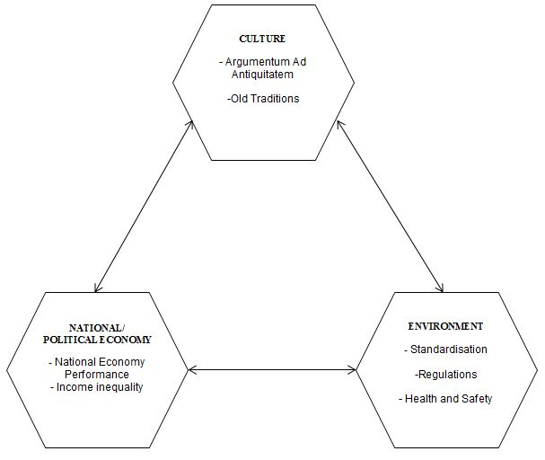
Figure 1: Conditions for the development of buildings’ end-of-life management in Nigeria

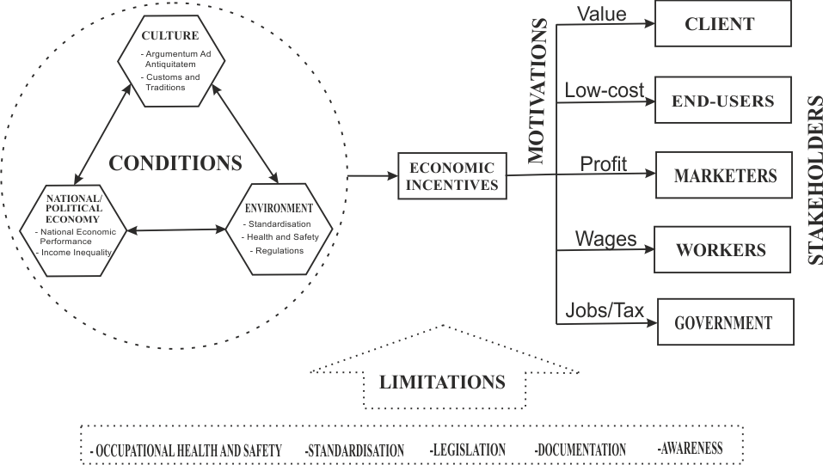
Figure 2: Mechanisms for controlling waste after building demolition in Kano
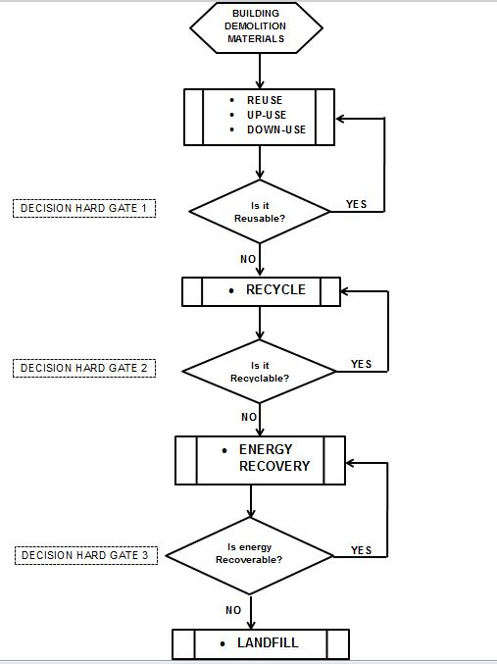

Figure 3: Handling of Waste Building Materials in Kano, Nigeria
Source: Adapted from Lee (2002)


Figure 4: African snail (http://www.fotolibra.com/gallery/41499/giant-african-land-snail-illustration/)

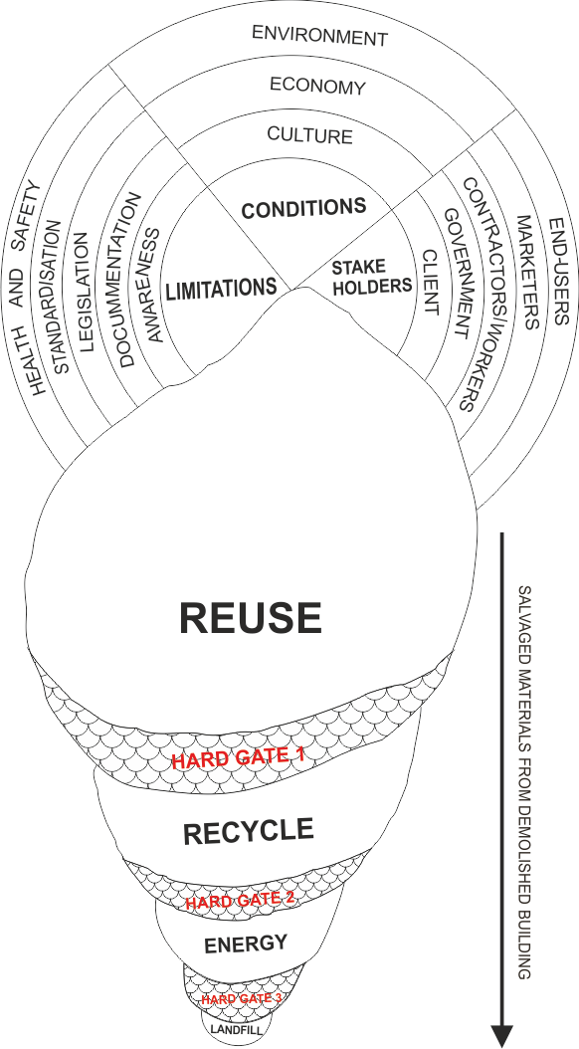
Figure 5: The Snail Filter (Authors’ conceptualisation)

