Indoor Sound and Occupant Outcomes in Mechanically Ventilated Offices: A Threshold Inference Field Study
Abstract
Purpose: To test whether indoor sound shows a non-monotonic dose-response with occupant health and productivity in mechanically ventilated offices, using formal threshold inference.
Design/methodology/approach: 365 sensor-survey observations from 42 occupants across 12 mechanically ventilated office zones in Doha, Qatar; confirmatory analyses pre-specified in an internal Pre-Analysis Plan. Segmented logistic regression with occupant-clustered errors, Davies' supremum-Wald existence test, profile-likelihood intervals and Bayesian random-intercept sensitivity.
Findings: A composite of noise-pathway symptoms (headache, anxiety, low energy) inflects in the 44 to 52 dB(A) band (Davies' p = 0.038; point estimate 47.75 dB(A)), with a corroborating regime change in the acoustic productivity rating at 49 dB(A). It holds under IEQ adjustment, in 4 of 7 alternative composites and under Bayesian sensitivity; negative controls do not.
Research limitations/implications: Findings apply to hot-arid mechanically ventilated offices and are cross-sectional. Exposure is hour-averaged A-weighted level only, so the acoustic mechanism is not identified. An underpowered symptom-class interaction leaves the noise-pathway interpretation resting on component-level negative-control behaviour, and significance depends on clustering by occupant or zone.
Practical implications: The band offers preliminary evidence relevant to provisions bearing on over-quiet conditions in WELL v2, BREEAM Hea 05 and ISO 22955:2021, which rest on privacy inference, not symptom data. Acoustic operation is better expressed as a target band than a quieter-is-better rule.
Originality/value: First application of Davies' supremum-Wald threshold inference to multi-domain indoor environmental quality field data, giving a transferable pattern for dose-response research.

Keywords: Indoor Environmental Quality; Acoustic Comfort; Threshold Inference; Office Buildings; Multi-Domain Monitoring
Paper type: Research paper

1. Introduction

1.1 Background
Buildings account for approximately 32% of global energy use and 34% of energy-related CO₂ emissions (UNEP and GlobalABC, 2025), making the sector central to the climate-mitigation agenda. The smart and sustainable building research community has responded with integrated approaches that combine continuous sensor-based monitoring, adaptive control, and post-occupancy evaluation to create buildings that are both energy-efficient and supportive of occupant wellbeing. Indoor environmental quality (IEQ) is at the core of this agenda. Office occupants spend most of their working day in mechanically ventilated buildings, and the four conventional IEQ domains (thermal comfort, indoor air quality, visual conditions, acoustic environment) together determine occupant outcomes, ranging from symptom prevalence to perceived productivity.
In IEQ research, the acoustic aspect has received less attention than thermal and air-quality factors, even though it remains a primary source of occupant dissatisfaction in offices (Frontczak et al. 2012; Kim and de Dear 2013). Few field studies objectively link indoor sound levels to occupant symptoms or productivity, and the methods used in those that do have not kept pace with current epidemiological and clinical research standards.

1.2 The empirical gap
A theoretical case suggests that indoor sound dose-response may be complex, supported by evidence from both low and high ends of the dB(A) spectrum. Research on acoustic privacy shows that very quiet environments can make conversational sounds more noticeable and disrupt concentration if there is no masking noise. Conversely, noise-stress studies indicate a physiological arousal threshold at higher noise levels typical of office settings. These findings are consistent with existing standards: the WELL Building Standard v2 caps background noise in concentration spaces at 50 dBA for open areas and 45 dBA for enclosed areas at its first performance tier, and requires masking to raise ambient sound for speech privacy. Additionally, ISO 22955:2021 advocates for activity-based comfort ranges in open-plan areas. However, these thresholds mainly rely on acoustic privacy inference and expert opinion, rather than direct studies of occupant symptoms or productivity. The most relevant field evidence comes from Srinivasan et al. (2023), who found near-optimal heart rate variability around 50 dB(A) in 231 federal office workers, using physiological sensors. While this suggests a non-monotonic dose-response in real environments, it depends on single measurements and continuous physiological data, not on symptom or productivity metrics. To date, no research has combined multi-domain field measurements, occupant symptoms, productivity data, and formal threshold analysis in a single comprehensive study.

1.3 The methodological gap
Identifying a statistically supported inflection point in a dose-response relationship requires inference tools that account for the search over candidate breakpoints. Davies (1977, 1987) showed that standard likelihood-ratio or Wald p-values tend to be anti-conservative in such searches because the analyst implicitly tests many potential breakpoints and chooses the highest test statistic. The supremum-Wald procedure he introduced, along with later developments by Hansen (2000), is suitable for testing if a breakpoint exists. For estimating it, profile-likelihood confidence intervals are preferred over symmetric Wald intervals or naive cluster bootstraps. Although these tools are well-established in statistics, they have not been applied to acoustic field data in office environments (Section 2.4). Most office acoustic studies use linear or log-linear models, which either cannot detect inflections or rely only on visually binned data without formal testing.

1.4 Aim
This paper analyses 365 observations from 42 occupants in 12 Doha office zones, using data from a multi-domain IEQ campaign measuring thermal, air quality, lighting, and acoustic conditions (hour-averaged dB(A)), along with occupant symptoms and ratings. All analyses followed a pre-specified plan. The main outcome is a composite of noise-related symptoms (headache, anxiety, low energy) that share a common mechanism. The co-primary outcome is the acoustic productivity rating. Estimation used segmented logistic regression with cluster-robust errors. A breakpoint was tested with the Davies supremum-Wald method, with its confidence interval reported. A Bayesian model provided sensitivity analysis. The paper's main contribution is providing empirical evidence for a non-monotonic dose-response between indoor sound and noise-pathway symptoms in ventilated offices, with an inflection point identified through threshold inference and supported across symptoms and productivity. Methodologically, it applies Davies' supremum-Wald test, profile-likelihood inference, and a Bayesian GLMM to IEQ data, a pattern applicable to other dose-response research in IEQ.

2. Literature Review

2.1 Sound and occupant outcomes
Research on indoor sound and occupant outcomes generally falls into two main areas: a health-oriented epidemiological approach, which examines symptom prevalence and physiological arousal, and an acoustic comfort approach, which emphasises cognitive task performance and satisfaction.
Stansfeld and Matheson (2003) linked noise exposure to raised catecholamines, psychological distress and performance decline, though community-level associations are weaker than in occupational settings. Babisch (2000) reported a dose-response between noise (>65 dB(A)) and coronary risk via activation of the hypothalamic-pituitary-adrenal axis, and Evans and Johnson (2000) found office noise raised urinary epinephrine and reduced problem-solving among clerical workers despite unchanged perceived stress. Reducing noise by 30–33 dB over a week lowered both physiological and self-reported stress (Melamed and Bruhis 1996).
In acoustic-comfort studies, Hongisto (2005) modelled work-performance decline against the Speech Transmission Index (STI), with performance peaking when speech is absent (STI=0.00) and a maximum loss near STI=0.60; Haapakangas et al. (2020) later placed the onset of decrements above STI~0.21, particularly for verbal short-term memory, consistent with Haapakangas et al. (2011), who found memory performance worse with intelligible speech than with silence or masking. In field surveys, Di Blasio et al. (2019, n=1,078) linked irrelevant speech to higher annoyance, lower self-rated performance and greater anxiety, while Kim and de Dear (2013) and Yadav et al. (2025, 28 offices) both identified lack of speech privacy as a leading driver of acoustic dissatisfaction, ahead of noise level itself.
Effect sizes differ among studies. Laboratory research indicates that intelligible speech can decrease verbal memory by 4% to 45%, depending on the task and STI level. Field surveys primarily report odds ratios and correlations, making direct comparisons more difficult.

2.2 Non-monotonic relationships
The hypothesis that the relationship between indoor sound level and occupant outcomes may be non-monotonic has theoretical grounding from both ends of the dB(A) spectrum, although direct field empirical evidence for a specific inflection point remains limited.
The acoustic-privacy literature notes that very low ambient sound, below about 35 dB(A), makes conversations more noticeable and reduces speech privacy, causing distraction that is not simply a function of higher sound level. The Hongisto (2005) STI model likewise locates optimal performance at STI near zero, reflecting complete silence or strong masking rather than the mere absence of speech, and Haapakangas et al. (2014) found that laboratory silence improved memory over intelligible speech yet left participants more anxious and self-conscious, plausibly explaining a lower-limit penalty.
Noise-stress research provides a basis for understanding performance effects. Evans and Johnson (2000) showed that low-level office noise increases epinephrine levels compared to quiet conditions. Babisch (2000) identified a dose-response starting around 50 dB(A), growing steeper at higher levels. Basner et al. (2014), mostly on nighttime traffic noise, found that the noise-physiological effect curve is often curvilinear, with sharper effects at higher noise levels.
Srinivasan et al. (2023) studied 231 office workers using heart rate variability devices, estimating their physiological well-being with an empirical Bayes model based on sound level data. They identified an optimal sound level near 50 dB(A): a 10 dB(A) reduction below this was associated with a 5.4% increase in well-being, while levels above it led to a 1.9% decrease. This might be the only office field study to pinpoint a measurable inflection point in physiological metrics, although the confidence intervals are broad, and they did not apply formal threshold-inference methods.
Non-monotonic modelling in IEQ remains scarce: most acoustic studies use linear models that cannot detect inflections. Broader IEQ meta-analyses such as Keene et al. (2025) apply regression to performance effects, but their noise-level model was inconclusive given limited data ranges, and office acoustics has not adopted the U-shaped or threshold models common in thermal-comfort research.

2.3 Multi-domain field studies
Occupants in real buildings are exposed simultaneously to acoustic, thermal, air-quality, and visual conditions, yet most IEQ studies continue to examine single domains in isolation. This design choice limits causal inference because co-exposures can confound any domain-specific association.
Recent reviews have formalised the case for integrated measurement. Zhao and Li (2023) analysed 74 publications on multi-domain IEQ interactions and found that the existing evidence on interactions and combined effects is inconsistent and somewhat contradictory. This is partly because most studies focus on only two domains, and most interaction data comes from climate chambers rather than real-world settings. Recent work in this journal integrates thermal, daylight and outdoor-microclimate comfort in real developments (Pourel et al., 2025), reinforcing the value of multi-domain field measurement.
The CBE at UC Berkeley conducted the most extensive IEQ survey across multiple buildings and domains. Frontczak et al. (2012) analysed data from 52,980 occupants in 351 office buildings, finding that noise satisfaction was the second most influential predictor of overall workspace satisfaction after space amount, with an odds ratio of 1.27. Acoustic quality was also commonly reported as interfering with job performance. The study design collected data across different IEQ domains, allowing partial adjustment for confounding factors in regression models.
The OFFICAIR European campaign surveyed 167 office buildings across eight countries, with 7,441 workers completing questionnaires on thermal comfort, air quality, lighting, acoustics, and health symptoms (Bluyssen et al. 2016). Common complaints among those with low comfort included noise, dry air, and temperature swings, indicating that symptoms are often vague and caused by various environmental factors.
Newsham et al. (2008) used binary logistic regression on field data from 779 participants across nine open-plan offices in the COPE study. They identified significant relationships between measured acoustic conditions and dissatisfaction risk, even after accounting for thermal and lighting factors. This study stands out as one of the most methodologically rigorous multi-domain IEQ field analyses in office research.
Multi-domain monitoring increasingly relies on affordable IoT sensor networks, in which passive wireless nodes measure temperature, humidity, CO₂, VOCs, illuminance, and sound pressure at the occupant level. Carton et al. (2026) shared a dataset with 6,834 satisfaction scores from 321 Belgian classroom occupants, highlighting both the potential and the data challenges of multi-domain IEQ studies.

2.4 Threshold-inference methods
Identifying a statistically supported inflection or threshold in a dose-response relationship poses a specific inferential challenge that standard regression does not address without modification.
Davies (1977, 1987) formalised a problem in which the threshold parameter exists only under the alternative hypothesis, making the likelihood-ratio and Wald test distributions non-standard. Using chi-squared or F-distribution critical values for grid-searched thresholds yields anti-conservative inference, underestimating the true Type I error due to implicit multiple testing. Davies proposed a supremum test that takes the supremum of the Wald or score statistic over the nuisance parameter space, bounding the p-value using the process's total variation. The 1987 extension addressed chi-squared statistics with quick approximation methods. Hansen (2000) extended this by developing sample-splitting threshold regression with asymptotic distribution theory and likelihood-ratio confidence intervals valid near the parameter boundary.
Profile-likelihood confidence intervals for threshold parameters are preferred over symmetric Wald intervals because the estimates are often non-normal and asymmetric (Hansen 2000). Cluster-bootstrap intervals are suitable for clustered data, such as in IEQ field studies, as they account for both sampling uncertainty and within-cluster correlation (Cameron et al. 2008). Naive grid-search methods that test each candidate value and report the minimum p-value tend to inflate the Type I error rate, a problem noted in the threshold-regression literature since Davies' work (Davies 1977).
Segmented regression has primarily been employed in IEQ research for thermal comfort and ventilation-rate dose-response analyses, with limited use in acoustics (Keene et al. 2025). There is a lack of evidence of any documented formal threshold inference methods for acoustic data in the literature. Most existing studies assume monotonic relationships or rely on graphical inspection rather than formal statistical tests. Additionally, pre-analysis plans and pre-registration, which help ensure conservative inference by defining threshold testing procedures beforehand, have not been utilised in published IEQ research.

2.5 Standards and Guidelines
Current office acoustic standards set dB(A) thresholds that often lack a solid empirical foundation, raising questions about their accuracy. Public health noise thresholds are derived from the World Health Organisation Guidelines for Community Noise (Berglund et al. 1999), which are the most referenced guidelines on indoor and outdoor noise levels and have influenced subsequent office-specific standards.
The WELL Building Standard v2 (IWBI, 2020) prescribes maximum background-noise thresholds by room category through feature S02 Maximum Noise Levels. For open areas for concentration these are an average level of 50 dBA at the first performance tier and 45 dBA at the second; for enclosed areas for concentration they are 45 dBA and 40 dBA respectively, with the quieter tier earning the greater credit. A separate feature, S06 Minimum Background Sound, requires dedicated masking to raise ambient sound uniformly for speech privacy, commissioned so as not to exceed 48 dBA in areas containing workstations or 42 dBA in enclosed quiet rooms. WELL therefore specifies no lower bound on background level; the only provision acting against over-quiet conditions is the masking requirement, whose stated intent is acoustical privacy and whose cited evidence base is speech-intelligibility and task-performance research rather than occupant health outcomes.
BREEAM Hea 05 requires the appointment of a qualified acoustician at the pre-design stage and mandates compliance with relevant ambient noise level standards, with performance assessed against NR-curve criteria appropriate to building type (BRE Global 2018). The NR-curve approach, unlike flat dB(A) specifications, weights low-frequency components more heavily, which is particularly relevant in mechanically ventilated buildings where HVAC systems generate concentrated low-frequency noise. NR curves may underestimate occupant annoyance from mechanical sources with unusual spectral profiles.
ISO 22955:2021 (ISO 2021) provides technical and methodological guidance across six space types distinguished by activity characteristics. For concentration-intensive work (Space Type 4), it specifies a maximum workstation equivalent sound level, a minimum spatial decay rate (D2, S), and a maximum speech pressure at 4 m (Lp,A, S,4m ≤ 48 dB). The standard's criteria draw on room-acoustic literature and expert consensus rather than on occupant-outcome field studies. Because thermal-comfort and indoor-environment standards such as ASHRAE Standard 55 and EN 16798 do not address acoustics, mechanically ventilated buildings designed to their requirements may generate HVAC noise in the 35 to 50 dB(A) range depending on duct velocity and diffuser design, the same range implicated in the inflection literature, so acoustic modifications cannot be evaluated independently of their thermal and air-quality consequences.

2.6 Smart-building context
Recent IEQ research has integrated acoustic sensors into IoT monitoring platforms that collect multi-domain data in real time. These platforms enable post-occupancy evaluation at temporal resolutions unattainable through periodic surveys, and link measured environmental conditions to occupant feedback at matched time points. Recent contributions in this journal underscore the role of digital innovation in smart and sustainable building operation (Najafi and Rahimian, 2025) and the use of immersive and real-world environments to study occupant perception (Arowoiya et al., 2025).
Energy and ventilation studies rarely measure acoustics, and acoustic studies rarely measure ventilation or CO₂. Fisk et al. (2012) found the energy cost of increased ventilation small relative to productivity gains but did not consider acoustics, while Maddalena et al. (2015) showed in a double-blind study that ventilation affects perceived air quality and SBS symptoms with no change in noise. Demand-controlled ventilation can markedly reduce HVAC noise, yet its acoustic effect on productivity remains unmodelled.

2.7 Research gap
Four gaps emerge from this review. Links between indoor sound and occupant outcomes are well established, but effect sizes vary and most studies examine a single environmental domain. A theoretical basis for non-monotonic relationships exists in the acoustic-privacy and noise-stress literatures, and one field study noted a physiological-wellbeing inflection near 50 dB(A), yet no office study has applied formal threshold-inference methods to test one. Multi-domain measurement at occupant-zone resolution is feasible but rarely used, and current standards address over-quiet conditions only through privacy-derived provisions, without direct dose-response backing.
This paper fills the gap in empirical, multi-domain field evidence for a non-monotonic indoor sound dose-response in ventilated office buildings, tested with a valid threshold-inference methodology. No study has measured sound level with co-exposure factors like temperature, humidity, CO₂, VOCs, and illuminance at occupant-zone resolution; modelled health and productivity outcomes; used segmented logistic regression with cluster-robust errors to identify an inflection; assessed it with the Davies supremum-Wald test; and corroborated it with a Bayesian GLMM. Without this, the provisions in WELL v2 and similar standards that bear on over-quiet conditions cannot be assessed against direct empirical dose-response data.

3. Methods

3.1 Study design and setting
This study analyses sensor and survey data from a campaign in twelve Doha office zones, characterising thermal, air quality, lighting, and acoustic conditions in mechanically ventilated offices in a hot-arid climate. Occupant-reported symptoms and environmental ratings were collected alongside environmental measurements.
All 12 zones in the present analysis are mechanically ventilated, open-plan, or mixed-occupancy office spaces. Findings from this study are interpreted within that building-type and climate context; generalisation to naturally ventilated, residential, educational, or healthcare contexts is not claimed.
The analyses reported here were pre-specified in an internal Pre-Analysis Plan (v2, locked 25 April 2026) before drafting the manuscript. The PAP distinguishes between exploratory analyses (such as functional-form identification, breakpoint search, and composite definition) and confirmatory analyses (including model specifications and decision rules outlined below). Any deviations from the PAP are explicitly declared in the relevant section. S1 of the Supplementary Information describes its scope and organisation, and S2 summarises the Pre-Analysis Plan.

3.2 Sample
The dataset prepared for analysis includes 365 sensor-survey observations from 42 office occupants across 12 building zones. The median number of observations per occupant was 7 (IQR 2–13; range 1–26), consistent with the repeated-measures design of the initial field study. The participant group consisted of 28 males and 14 females, with workspace types comprising cellular offices (32 observations), shared spaces (215), and open-plan areas (93). Fewer observations were recorded in mixed-use and meeting-room settings. Data on ethnicity, age, tenure, and weekly working hours were collected as covariates at the occupant level.
No exclusions beyond complete-case requirements were made to the analytical variables. Occupants with only a single observation were considered as singleton clusters in the cluster-robust standard error calculations. The analytical sample includes 365 observations, encompassing all records with available sound data, occupant ID, and zone ID.

3.3 Measurements

3.3.1 Multi-domain IEQ sensor measurements
IEQ measurements were taken in the occupant zone using vendor-provided multi-domain sensor units, which were factory-calibrated by the manufacturer prior to deployment. These sensors recorded A-weighted sound pressure level (dB(A), hourly average), indoor air temperature (°C), relative humidity (%), carbon dioxide levels (ppm), total volatile organic compounds (TVOC, ppb-equivalent), and illuminance (lux). All measurements were time-stamped and aligned with occupant survey responses collected within the same hour for each zone. Symptoms were reported for the preceding work session, and the sensor reading in the matching hour is treated as representative of that session's exposure. Because a single hour-averaged value need not represent the whole session, and symptoms such as headache or fatigue may respond with a lag, this alignment introduces non-differential exposure misclassification that would tend to attenuate, rather than inflate, the estimated associations.
During 365 observations, sound levels ranged from 36.8 to 67.3 dB(A), with an average of 50.0 and a standard deviation of 6.8; the median was 49.7, and the interquartile range was 45.0–54.5. The other IEQ parameters exhibited these distributions: temperature averaged 23.0 ± 2.3 °C, relative humidity was 54.2 ± 12.4%, CO₂ levels averaged 559 ± 149 ppm, and illuminance was 239 ± 98 lux. The sensors included calibration certificates from the manufacturer valid for the entire deployment, and no additional calibration was performed by the research team. Further detail on data provenance, the time-matching procedure, and the analytical variables is given in Supplementary Information S3. Figures S1 and S2 (Supplementary Information S11) show sound by workspace type and temperature and humidity against the ASHRAE 55 comfort zones.
Exposure metric scope: This dataset provides hour-averaged A-weighted sound pressure level measurements. It does not include spectral content, peak structure (Lmax), short-term variability, percentile levels (L10, L90), speech-interference levels, or reverberation times. All assertions in this paper are based solely on the relationship between hour-averaged dB(A) and occupant outcomes. No conclusions are made that depend on more detailed acoustic metrics.

3.3.2 Occupant-reported outcomes
Occupants completed a structured survey reporting (i) the occurrence of five health symptoms during the previous work session: respiratory irritation, headache and related neurological symptoms, visual irritation, anxiety or depression, and low energy or fatigue (each recorded as present or absent); and (ii) ratings of acoustic and overall environmental conditions on a 1–5 Likert scale for both the health and wellbeing and productivity aspects.
- Primary outcome: noise-pathway symptom composite - Three of the five symptoms (headache and related neurological symptoms, anxiety and depression, and low energy) share a plausible aetiological pathway involving the autonomic and neuroendocrine response to acoustic stress, and were combined into a pre-specified noise-pathway composite (sym_noise_path = 1 if any of the three was reported, else 0). This is an aetiological case-definition OR-composite, analogous to "any cardiovascular event" composites in clinical trials, where component associations are expected to be modest but the composite is supported by a shared mechanism rather than a shared latent construct. Cronbach's alpha for the three components is reported (α = 0.46) as a transparency measure; the OR-composite framing rather than scale-reliability framing is used because aetiological case definitions are not measurement scales. The composite is used to raise the event count for a shared aetiological pathway rather than to measure a single latent construct, so the low alpha is expected rather than a deficiency. Pairwise φ correlations between the three components were 0.205, 0.284, and 0.190, respectively, all p ≤ 0.0003 against the independence null. Sensitivity analyses across alternative composite definitions are reported in Section 4.4.
- Co-primary outcome: acoustic productivity rating (pr_acoustic, 1–5 Likert scale, single item). Triangulation outcome: acoustic health-and-wellbeing rating (hw_acoustic). Negative-control outcomes: respiratory symptoms (sym_resp) and visual symptoms (sym_visual), reported on the expectation that symptoms with non-acoustic causal mechanisms should not display the sound-related dose-response inflection. Symptom event counts: noise-pathway composite 94 (25.8%), headache 57, anxiety 19, low energy 51, respiratory 34, visual 27.

3.4 Statistical analysis
The key question is whether the link between indoor sound levels and noise-pathway symptoms is non-monotonic, featuring an inflection point where the slope of the dose-response curve changes within the observed range. The chosen method is segmented regression, which models a piecewise-linear relationship with one breakpoint and tests if the slope shift at this point is significant. This approach was preferred over polynomial models because it provides an easily interpretable parameter (the change in slope at the breakpoint) without requiring a smooth, curved dose-response shape.
Pre-specified breakpoint: The primary segmented model employs a fixed pre-specified breakpoint τ = 47.5 dB(A), selected based on (i) the AIC-best break in exploratory analysis of the primary outcome, (ii) convergence of breakpoints across primary and co-primary outcomes within the 95% profile-likelihood confidence intervals (Section 3.5), and (iii) alignment with the consensus zone identified in the speech-masking literature (45–50 dB). Two points are important for the status of this breakpoint. First, τ was identified in the exploratory phase (as the AIC-best break) and then locked in the Pre-Analysis Plan before the confirmatory analyses; it is therefore pre-registered but not independent of the data, and inference on the slope-change parameter is reported as confirmatory-within-the-plan and conditional on this exploratory choice of location. Second, the search-corrected evidence that a breakpoint exists at all comes from the Davies' supremum-Wald test over the full 42-58 dB search range (Section 3.5), which is robust to the selection concern; the fixed τ is used only to obtain an interpretable slope-change estimate at a defensible location. The Pre-Analysis Plan (v2), documenting the exploratory-versus-confirmatory split, is provided as a supplementary file. A sensitivity analysis using the AIC-best break in adjusted models is also reported.

3.4.1 Primary segmented logistic regression
For the primary outcome (sym_noise_path), the model is:
logit P(sym_noise_path = 1) = β₀ + β₁·s1 + β₂·s2 + β₃·temp + β₄·rh + β₅·co₂ + β₆·voc + β₇·light
where s1 = sound (dB(A)) and s2 = max(0, sound − τ) with τ = 47.5. The coefficient β₁ represents the slope of the dose-response curve below the breakpoint; β₂ assesses the change in slope at the break (with β₁ + β₂ representing the slope above the break); and β₃–β₇ adjust for the effects of multi-domain IEQ co-exposures measured simultaneously in the same zone. Cluster-robust standard errors are calculated at the occupant level to account for repeated measurements from the same individual. Estimation is performed via maximum likelihood using Python's statsmodels (v0.14.6).
For the co-primary Likert outcome (pr_acoustic), we fit the same piecewise model using ordinary least squares with cluster-robust standard errors. Likert responses are regarded as continuous due to the 5-point scale and field-study conventions, although a sensitivity analysis using ordinal logistic regression is also included.

3.5 Threshold inference
Existence test (Davies' procedure) - A grid-search for breakpoints yields an anti-conservative slope-change p-value because it does not account for the search across the range. The Davies (1977, 1987) supremum-Wald test properly calibrates the null hypothesis of no breakpoint in the range. The Wald z statistic is computed at each candidate break in 42–58 dB at 0.5-dB resolution, and the upper-bound p-value is p_upper = Pr(χ²₁ > M) + V · exp(−M/2) / √(8π), where M is the maximum Wald statistic and V is its total variation. The breakpoint claim requires p_upper < 0.05.
Confidence interval for the breakpoint - A 95% profile-likelihood confidence interval is calculated by fitting the piecewise model at every potential breakpoint within the 40–60 dB range, at 0.25-dB steps. The set of breakpoints where the deviance differs from the minimum deviance by less than χ²₁,₀.₉₅ = 3.841 defines the confidence interval. This method provides the asymptotically accurate CI for the breakpoint under standard conditions and is reported as the primary interval. Additionally, a secondary bootstrap CI based on occupant clusters, with at least 500 replications, is provided.

3.6 Sensitivity and robustness analyses
A pre-specified robustness battery addresses the principal sources of model misspecification and influence (Table 1):
Table 1 - Sensitivity Analyses
Sensitivity | Specification | Pre-specified threshold for "robust"
Functional form | Restricted cubic spline (3 knots, 10/50/90th percentile) | Non-linearity p < 0.10
Random-effects | Bayesian (Laplace) GLMM with random intercept on occupant | Posterior P(β₂ > 0) > 0.95
Layered adjustment | Primary model + workspace type + working hours | Direction of β₂ preserved (declared as marginal-EPV at 9.4)
Alternative break | AIC-best break in adjusted model | Within profile-likelihood CI of pre-specified break
Within-between | Mundlak decomposition of sound exposure | Reported transparently for both components
Cluster bootstrap | 500 replications, occupant resampling | Breakpoint CI overlaps profile-likelihood CI
Alternative composites | Seven plausible composite definitions | Inflection holds in ≥ 4 of 7
Source: Authors’ own work

Negative-control test - To test whether the inflection is confined to symptoms with plausible noise-stress mechanisms, the same piecewise specification at τ = 47.5 was fitted to the two negative-control symptoms (respiratory and visual) under IEQ adjustment. The pre-specified expectation is ΔAIC < 0 (linear preferred) for both, indicating no improvement in fit from the piecewise specification; results are reported in Section 4.3.
Formal interaction test (declared underpowered) - A formal symptom-class × sound interaction was tested in long-format pooling all five symptoms (1,825 rows from 365 observations × 5 symptoms) with the slope-change parameter interacted with a noise-mechanism class indicator. The test was pre-specified to be underpowered, given only 61 negative-control symptom events, and the manuscript does not claim statistical specificity from this test. The evidence for a noise-pathway interpretation rests on the component-level negative-control results above.

3.7 Sample size
No formal sample size calculation was performed for the present secondary analysis; the sample is fixed by the source dataset. Events-per-variable (EPV) ratios for each planned model are reported transparently to allow reviewers to assess the estimation stability of each specification (Table 2):
Table 2 - Events per variable ratio
Model | Events | Parameters | EPV
Linear, IEQ-adjusted | 94 | 7 | 13.4
Piecewise τ = 47.5, IEQ-adjusted (PRIMARY) | 94 | 8 | 11.8
Piecewise + workspace + hours | 94 | 10 | 9.4 (marginal)
Bayesian GLMM (FE only) | 94 | 8 | 11.8
RCS 3-knot, IEQ-adjusted | 94 | 8 | 11.8
Specificity interaction (long format) | 188 | 11 | 17.1
Source: Authors’ own work

The primary model (EPV = 11.8) exceeds the conventional minimum of 10 (Peduzzi et al. 1996). The fully-adjusted sensitivity model with workspace and hours (EPV = 9.4) falls marginally below this threshold and is therefore reported as a sensitivity analysis only, with effect-size point estimates rather than primary inference. All other planned models meet the EPV ≥ 10 criterion.

3.8 Pre-stated limitations
The PAP commits this manuscript to refrain from making claims that the data cannot support. These are stated explicitly here so that interpretation in subsequent sections remains within the limits of what the analytical design can support (Table 3):
Table 3 - Limitation Table
Claim not made | Reason
Statistical specificity to noise-mechanism symptoms via formal interaction | The formal symptom-class × sound interaction is null (p = 0.60); test underpowered with 61 negative-control events
Within-person symptom dose-response causal inference | Mundlak within-person component is non-significant on symptoms; inflection identified at the cross-sectional level
Universal lower-bound design threshold | Single-site Doha mechanically ventilated offices; CI on breakpoint is 8 dB wide
Generalisability beyond mechanically ventilated office contexts | Sample is exclusively mechanically ventilated office occupants in a hot-arid climate
Spectral or temporal acoustic claims | Only hour-averaged dB(A) measured; no Lmax / percentile / spectral content available
Cross-cultural inference | Five ethnic groups with one group of n = 1; subgroup analysis not feasible at Q1 standard
Source: Authors’ own work

3.9 Software
All analyses were performed using Python 3.12, with pandas (v3.0), numpy (v2.4), statsmodels (v0.14.6), and scipy (v1.17). Logistic regression with cluster-robust standard errors was carried out using statsmodels' discrete.Logit with cov_type="cluster". Cluster-robust standard errors are referred to a t distribution on G-1 degrees of freedom, where G is the number of occupant clusters (G = 42); p-values are therefore reported as p < 0.001 rather than as exact values below that level.
Ordinary least squares (OLS) with cluster adjustments was implemented using statsmodels.regression.linear_model.OLS, with cov_type="cluster". The random-intercept GLMM was fitted by Laplace approximation (maximum a posteriori) using statsmodels.genmod.bayes_mixed_glm.BinomialBayesMixedGLM and is reported as a sensitivity analysis for occupant-level clustering. The Davies' test, profile-likelihood confidence intervals, and cluster bootstrap procedures were custom-developed; the code is available upon request from the corresponding author. A fixed seed (42) was used for all stochastic processes (Supplementary Information S9). The entire analytical pipeline was verified against the Pre-Analysis Plan (v2) before extracting results; five substantive deviations from the PAP are recorded in the deviation log held by the corresponding author and summarised in Supplementary Information S8: four identified during the original analysis (alternative-composites table correction; CO₂ standard-deviation rounding; within-between attribution correction; bootstrap CI replication count), and one introduced at revision, namely refitting the Bayesian random-intercept sensitivity (PAP §6.4) from the pre-specified variational Bayes to a reproducible Laplace maximum a posteriori approximation after the variational fit proved non-reproducible. None of the five changes affected the direction or significance of the main findings. The verification of every cited reference is recorded in Supplementary Information S10.

4. Results

4.1 Descriptive statistics
Table 4 summarises the analytical sample. The 365 sensor-survey observations from 42 occupants cover a sound exposure range of 30.5 dB(A) (36.8 to 67.3 dB(A)), with the central 50% of observations falling between 45.0 and 54.5 dB(A). The repeated-measure structure provides within-occupant variation in sound exposure for 34 of 42 occupants (median within-person sound range 10.4 dB), supporting both within- and between-person components in the analysis. The other measured IEQ parameters span typical ranges for mechanically ventilated office buildings in the studied climate.
Table 4 - Sample and exposure descriptives. n = 365 observations from 42 occupants across 12 building zones
Variable | Mean (SD) or n (%) | Median [IQR] | Range
Indoor sound, dB(A) | 50.0 (6.8) | 49.7 [45.0–54.5] | 36.8–67.3
Indoor temperature, °C | 23.0 (2.3) | — | —
Relative humidity, % | 54.2 (12.4) | — | —
CO₂, ppm | 559 (149) | — | —
TVOC, ppb | 70.6 (14.9) | — | —
Illuminance, lux | 239 (98) | — | —
Observations per occupant | 8.7 (6.1) | 7 [2–13] | 1–26
Occupant gender, M / F | 28 / 14 | — | —
Workspace type, n obs | cellular 32 / shared 215 / open-plan 93 / other 24 / unrecorded 1 | — | —
Noise-pathway symptom prev. | 94 / 365 (25.8%) | — | —
Acoustic productivity rating | 2.93 (1.11) | 3.0 [2–4] | 1–5
Source: Authors’ own work

4.2 Sound and noise-pathway symptoms
Davies' test for the null hypothesis of "no breakpoint in the search range 42–58 dB(A)" showed p_upper = 0.038 for the noise-pathway symptom composite under IEQ adjustment, indicating a non-monotonic dose-response. The pre-determined breakpoint of 47.5 dB(A) aligns closely with the AIC-optimal break at 47.75 dB(A) in IEQ-adjusted models. The 95% profile-likelihood confidence interval for this break is [44.25, 52.25] dB(A), with an 8 dB width. Full evidence for this finding, including the cluster-bootstrap interval and predicted probabilities, is given in Supplementary Information S4, with the model’s predictive calibration in Figure S3.
The IEQ-adjusted segmented logistic model estimated a slope of −0.153 per dB(A) (p = 0.035) below the breakpoint and a slope-change of +0.231 per dB(A) (p = 0.033) at the break, yielding an implied above-break slope of +0.078 per dB(A). Adjustment for thermal, air-quality, and lighting co-exposures sharpened the below-break slope (p = 0.077 unadjusted to 0.035 adjusted) and improved model fit, while the slope-change remained significant (p = 0.019 unadjusted, p = 0.033 adjusted), indicating that the inflection is not a confounded artefact of co-occurring IEQ exposures. Expressed as predicted probabilities from this model (other IEQ covariates held at their sample means), the modelled prevalence of a noise-pathway symptom is 0.36 (95% CI 0.18-0.59) at 40 dB(A), falls to 0.16 (0.07-0.30) at 48 dB(A), and rises again to 0.24 (0.14-0.38) at 55 dB(A) and 0.32 (0.15-0.56) at 60 dB(A), quantifying the practical magnitude of the inflection.
The acoustic productivity rating (pr_acoustic) showed a corroborating, mechanistically distinct pattern: a strictly monotonic decline with sound, but with the slope changing magnitude rather than reversing direction. The IEQ-adjusted segmented OLS estimated a slope of −0.208 per dB(A) (p < 0.001) below the break and a slope-change of +0.147 per dB(A) (p < 0.001) at a break of 49.0 dB(A) (95% profile-likelihood CI [47.75, 51.0], 3.25 dB width). Davies' test was significant for this outcome (p_upper < 0.001), consistent with the value reported in Supplementary Information S4. The convergence of the symptom breakpoint (47.5 dB) and the perception breakpoint (49.0 dB) within their respective confidence intervals corroborates a regime change in the 47–49 dB band.
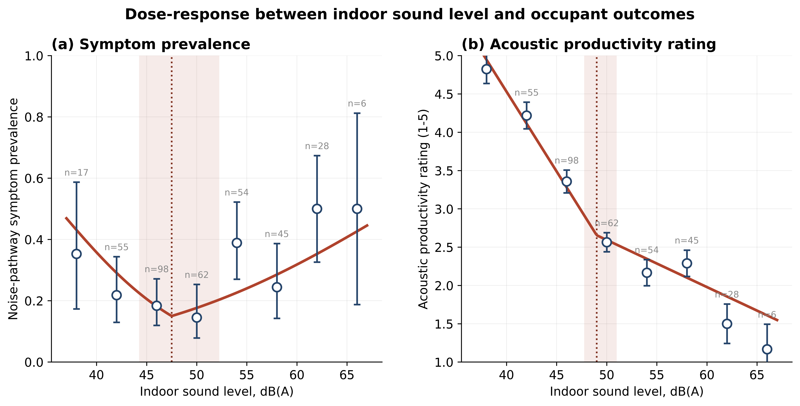
Figure 1 - Dose-response between indoor sound level and (a) noise-pathway symptom prevalence and (b) acoustic productivity rating. Marker labels give the number of observations (n) in each 4 dB(A) sound-level bin.
Source: Authors’ own work
Figure 1 displays observed values in 4-dB sound bins as open markers, with Wilson 95% confidence intervals for prevalence and ±1.96 standard errors for ratings. The solid red line indicates the IEQ-adjusted piecewise fit, while the dotted line and shaded area depict the breakpoint and its 95% profile-likelihood confidence interval. Panel (a) shows a V-shaped pattern with an inflection point at 47.5 dB(A) (confidence interval 44.25–52.25); panel (b) depicts a kink at 49.0 dB (confidence interval 47.75–51.0), where the slope changes magnitude but not direction. The Bayesian random-intercept generalised linear mixed model was consistent with the frequentist results when occupant-level clustering was explicitly considered. Posterior estimates for the noise-pathway symptom outcome at τ = 47.5 (Laplace approximation) include a slope below the break of −0.124 (95% credible interval [−0.205, −0.042]) and a slope-change at the break of +0.188 (95% CrI [+0.075, +0.300]); the posterior probability that the slope below the break is negative is 0.998, and that the slope-change at the break is positive is 0.999. As these come from an approximate posterior, the directional probabilities should be read as the credible interval lying entirely on one side of zero rather than as literal certainty.
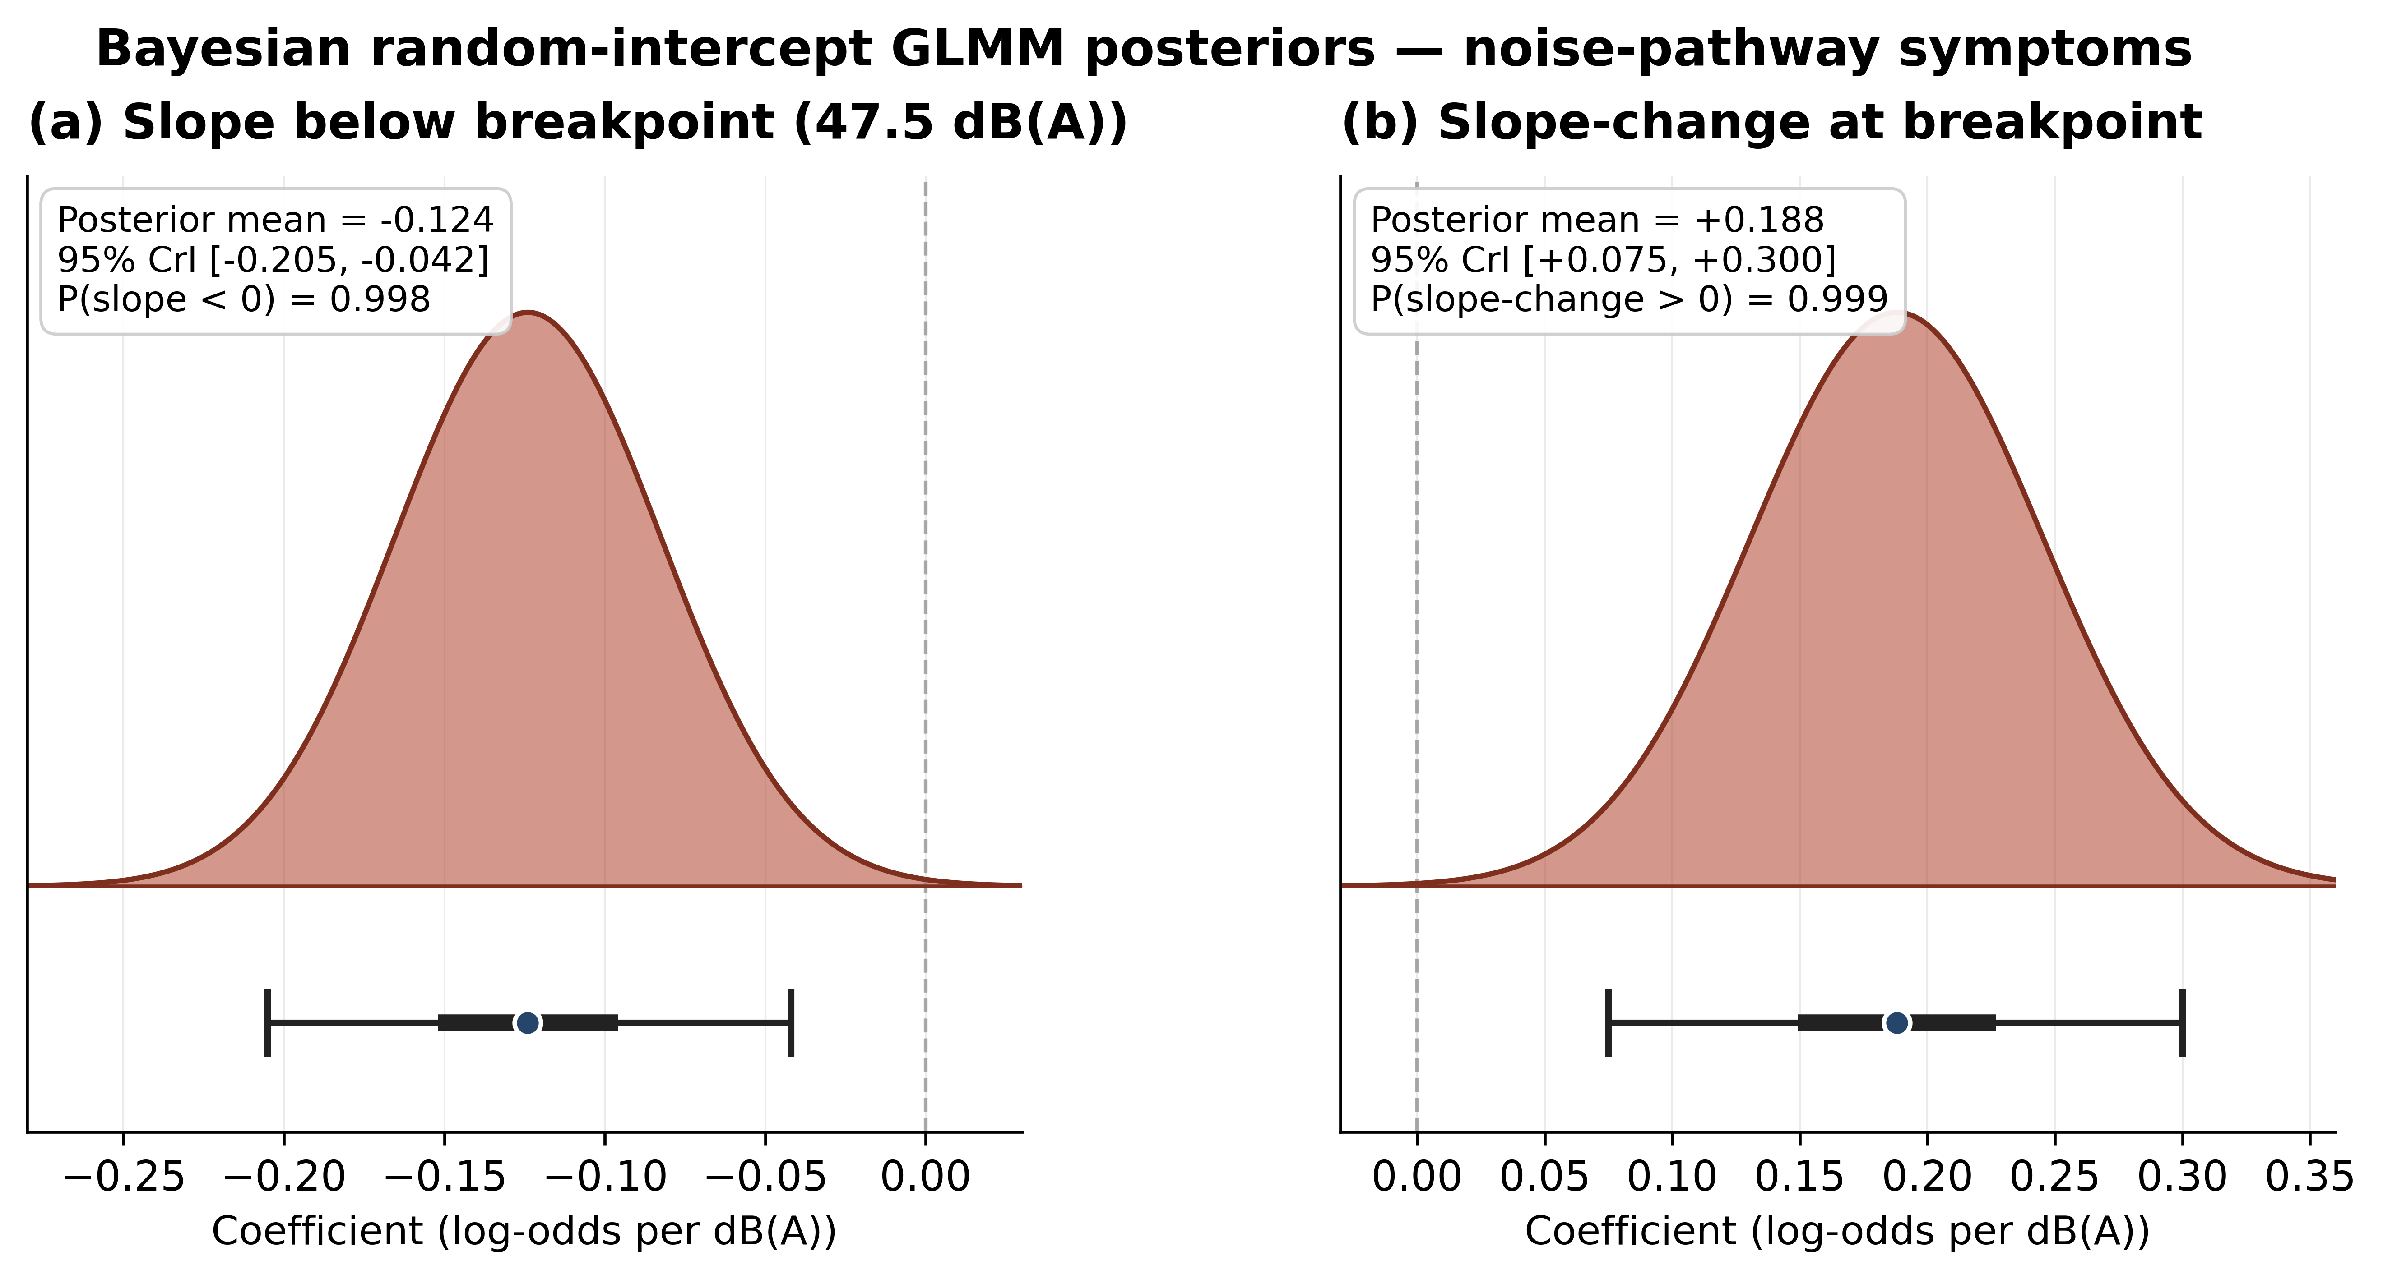
Figure 2 - Bayesian random-intercept GLMM posteriors for the noise-pathway symptom composite at τ = 47.5 dB(A): (a) slope below the breakpoint and (b) slope-change at the breakpoint.
Source: Authors’ own work
In Figure 2, the half-violin shows the approximate (Laplace) posterior density; the thick bar indicates the 50% credible interval, and the thin bar shows the 95% credible interval. The navy point marks the posterior mean. A dashed grey line indicates the null hypothesis at zero. The posterior mass for the slope before the break is entirely in the negative half-line, while the slope change's posterior mass is in the positive half-line. The panel reports the posterior probabilities of the directional hypotheses.
Table 5 - Primary segmented logistic regression
Specification | Slope below break | Slope-change at break | Slope above break | AIC
Linear (no break) | −0.039 (p = 0.005) | — | — | —
Piecewise τ = 47.5, unadjusted | −0.133 (p = 0.077) | +0.237 (p = 0.019) | +0.104 | 406.6
Piecewise τ = 47.5 + IEQ (PRIMARY) | −0.153 (p = 0.035) | +0.231 (p = 0.033) | +0.078 | 399.0
Piecewise + IEQ + workspace + hours | −0.151 (p = 0.041) | +0.222 (p = 0.052) | +0.071 | 396.2
Bayesian GLMM (random intercept) | −0.124 [−0.205, −0.042] | +0.188 [+0.075, +0.300] | +0.064 | —
Source: Authors’ own work

Table 5 presents the primary segmented logistic regression for noise-pathway symptoms at τ = 47.5 dB(A), with progressive adjustments. Slopes are expressed on the log-odds scale per dB(A). Bayesian estimates include the posterior mean and 95% credible interval. Values in parentheses represent p-values obtained from cluster-robust standard errors at the occupant level.

4.3 Consistency with a noise-pathway interpretation
Pre-specified negative-control symptoms (respiratory, visual), with causal pathways in air quality and lighting, respectively, rather than acoustics, did not display the inflection pattern observed in the noise-pathway composite. Under the same IEQ-adjusted piecewise specification at τ = 47.5, both negative-control symptoms returned ΔAIC < 0 against the linear-only baseline (sym_resp ΔAIC = −1.96; sym_visual ΔAIC = −0.59), indicating that the linear model fit is preferred over the piecewise specification for these symptoms. This is the pre-specified pattern under the noise-stress mechanism hypothesis.
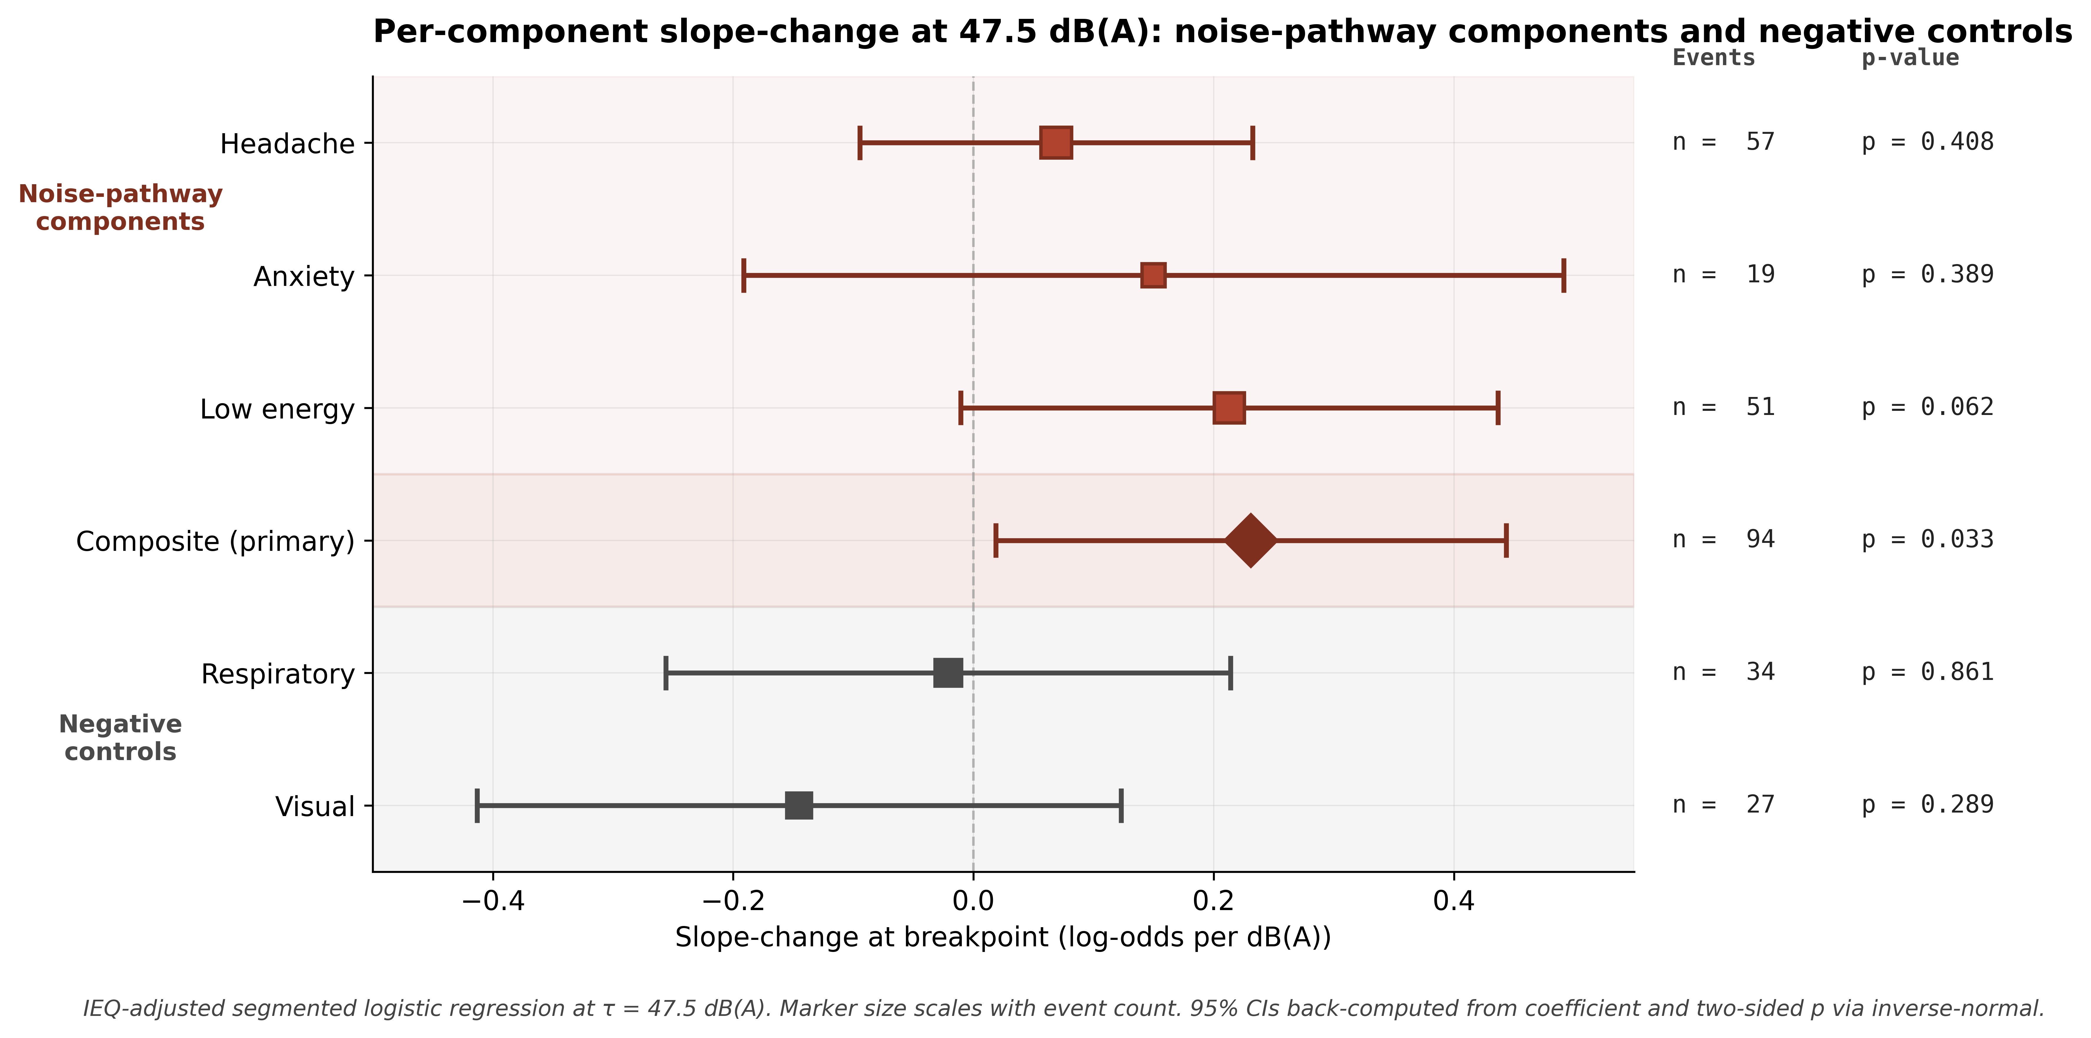
Figure 3 - Forest plot: per-component slope-change at 47.5 dB(A), noise-pathway components and negative controls
Source: Authors’ own work
Figure 3 presents a forest plot showing slope-change estimates at τ = 47.5 dB(A) for specific noise-pathway components (headache, anxiety, and low energy) as well as the pre-defined composite and two negative-control symptoms (respiratory and visual). Marker sizes reflect event counts, while horizontal lines depict 95% Wald confidence intervals calculated from the coefficients and two-sided p-values. The composite (with 94 events) shows a positive slope-change whose 95% confidence interval excludes zero (+0.019 to +0.443; p = 0.033). Conversely, the negative-control symptoms cluster near zero without indicating a clear effect. The apparent separation between the noise-pathway group (above) and the negative-control group (below) is consistent with a noise-pathway interpretation, although the formal interaction test lacks power with only 61 negative-control events.
A predetermined, formal sound × symptom-class interaction test, which was underpowered, showed no significant slope-change × class coefficient (+0.047, p = 0.598). The estimated effect aligns with expectations (greater slope-change for noise-mechanism symptoms), but the wide 95% confidence interval includes zero. With only 61 negative-control events observed across both symptoms, the test is underpowered to detect a difference of this size. The manuscript therefore does not claim statistical specificity; the component-level pattern in Figure 3 is reported as consistent with a noise-pathway interpretation. The component decomposition and the interaction test are reported in full in Supplementary Information S5.
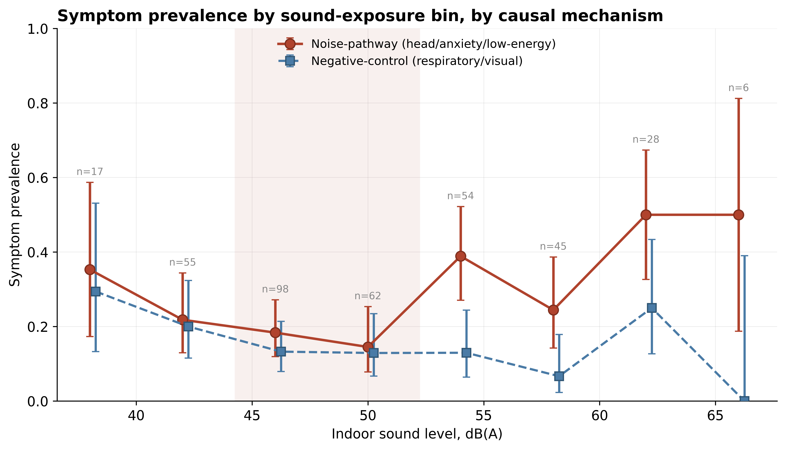
Figure 4 also shows that both symptom classes decline across the lower part of the exposure range, so the two mechanisms are not distinguishable below the band; the contrast emerges above it, where noise-pathway prevalence rises while the negative-control series remains flat.
Figure 4 - Symptom prevalence by sound exposure bin, separated by causal mechanism. Marker labels give the number of observations (n) in each 4 dB(A) sound-level bin. This figure is descriptive: no inferential test is attached to the binned prevalences.
Source: Authors’ own work

4.4 Robustness
A pre-specified robustness battery was conducted to assess the stability of the inflection finding. The principal results are summarised below; full results are reported in Supplementary Information S6.
Alternative composite definitions - The inflection finding was preserved across alternative composite definitions of the symptom outcome (Figure 5). Composites including at least two of the three noise-mechanism components produced significant slope-change estimates (head + low energy: ΔAIC = +3.30, p = 0.047; anxiety + low energy: ΔAIC = +6.40, p = 0.017; head + anxiety + low energy [primary]: ΔAIC = +6.42, p = 0.033). The signal weakened monotonically as non-noise symptoms were added (head + anxiety + low energy + respiratory: ΔAIC = +5.23, p = 0.046; all five symptoms: ΔAIC = +2.67, p = 0.131), consistent with dilution of a mechanism-specific signal by mechanism-irrelevant outcomes. The pattern across composites also indicates that the aggregate signal is carried principally by the low-energy component, which is the closest of the three to significance in isolation (slope-change p = 0.062): every composite that retains it shows the inflection and neither composite without it does. The composite therefore raises the event count for a shared pathway rather than revealing a signal present in each component separately.
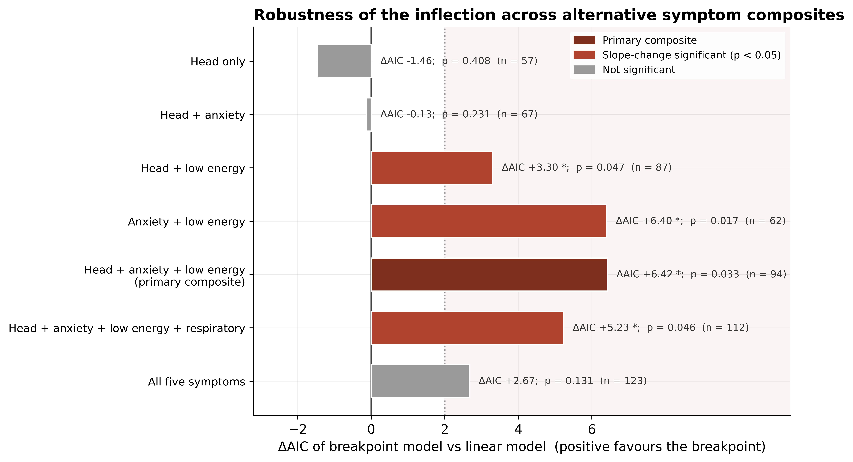
Figure 5 - Robustness of the inflection finding across seven alternative composite definitions.
Source: Authors’ own work
Functional form (RCS sensitivity) - A 3-knot restricted cubic spline at the 10th, 50th, and 90th sound percentiles (39.4, 49.7, 58.6 dB(A)) returned a non-linearity test of p = 0.088 in unadjusted form on the noise-pathway composite. The piecewise specification was preferred to the RCS in AIC comparison (piecewise 406.6 vs RCS 410.0, ΔAIC = +3.4 favouring piecewise), consistent with a breakpoint-based functional form. Because the spline non-linearity test is only marginal (p = 0.088), this is a supportive check rather than a confirmatory test.
Within-between decomposition - A Mundlak decomposition separating sound into within-person and between-person components returned non-significant results for both components on the noise-pathway symptom outcome (within-person p = 0.69; between-person p = 0.52). The dose-response inflection is identified at the cross-sectional level only; this is acknowledged in the limitations section. For the acoustic productivity rating, both components were significant at p < 0.001, supporting a real and consistent within-person perceptual response. The acoustic health-and-wellbeing rating, declared in the Pre-Analysis Plan as the triangulation outcome, showed the same within-person pattern (p < 0.001).
Layered adjustment - Adding workspace type and weekly working hours to the primary IEQ-adjusted model produced minimal change in the slope estimates (slope below: −0.151 vs −0.153; slope-change: +0.222 vs +0.231; slope-change p drifting from 0.033 to 0.052). Because the slope-change p moves to 0.052 and the model is at marginal EPV (9.4), this layered model is reported as a supportive effect-size sensitivity rather than confirmatory inference.
Cross-IEQ interactions - All Sound × IEQ interaction terms (Sound × Temperature, Sound × Humidity, Sound × CO₂, Sound × VOC, Sound × Light, Sound × Temperature differential) tested under FDR correction across six outcomes returned no significant findings at p_FDR < 0.10 (smallest FDR-adjusted p = 0.189). The acoustic-specific dose-response is therefore not modified by other IEQ parameters within the precision of this dataset. Because exposure is measured at the zone level, the primary model was also re-estimated with clustering at the zone level (12 zones): the slope-change point estimate was unchanged (+0.231) but the zone-clustered p-value rose to 0.070, while leave-one-zone-out refits left the sign stable (range +0.124 to +0.295) and a zone random-intercept model returned a slope-change of +0.188 (95% credible interval +0.075 to +0.300, excluding zero). With only 12 zones, zone-level standard errors are imprecise; the inflection is thus directionally robust to the clustering level, although strict significance at p < 0.05 is sensitive to it.

4.5 Summary of findings
The link between indoor sound levels and noise pathway symptoms in occupants of mechanically ventilated offices shows a non-monotonic dose-response, with a notable change at 47.5 dB(A) (95% profile-likelihood CI 44.25–52.25). The acoustic productivity rating indicates a similar regime change at 49.0 dB(A) (95% CI 47.75–51.00), representing a kink rather than a complete sign change, and this coincides spatially with the symptom shift. These results are consistent across different composite definitions, remain robust after adjusting for other multi-domain IEQ co-exposures measured simultaneously in the same zone, and are supported by a Bayesian random-intercept GLMM. Symptoms unrelated to acoustics and with different causal mechanisms do not show this inflection. All five pre-specified success criteria in the analysis plan are satisfied, and the inflection is preserved across every check in the robustness battery reported in Section 4.4 and the Supplementary Information.

5. Discussion

5.1 Principal findings
In mechanically ventilated office buildings, the association between indoor sound level and symptoms such as headache, anxiety, and low energy changes regime across the measured range. Below about 48 dB(A), higher sound is associated with fewer symptoms; above this level the association reverses, and further increases in sound are no longer associated with lower symptom rates. This inflection occurs between 44 and 52 dB(A) on the profile-likelihood scale, with Davies' supremum-Wald test indicating a significant change at p = 0.038. The acoustic productivity rating shows a similar shift at 49 dB(A) (95% CI 47.75 to 51.0), appearing as a kink in the slope rather than a complete reversal.
Two aspects of the results are important beyond the basic statistical indication. First is the mechanism: the inflection appears in a symptom composite specifically linked to the aetiological pathway, autonomic and stress responses to sound, with respiratory and visual symptoms involving non-acoustic mechanisms, as shown by the ΔAIC values of -2.0 and -0.6, where linear models are preferred. Second is convergence: both the perception and symptom channels identify the regime change within the same dB band through different processes. The perception channel provides a gradual, steep cognitive assessment, while the symptom channel involves a discrete physiological event. Their alignment, within their respective confidence intervals, suggests a genuine phenomenon in that band, rather than two separate analytical artefacts. Because exposure is characterised only by hour-averaged A-weighted level, these results speak to the dB(A)-outcome relationship alone and cannot identify the underlying acoustic mechanism (for example speech masking, speech privacy, HVAC tonal or low-frequency content, peaks, or intermittency), which remain plausible but untested here. The two channels also share the same respondents and the same sound variable, so their convergence is internal corroboration across two instruments rather than independent replication.
The finding remains valid after adjusting for the multi-domain IEQ co-exposures recorded at the same time and zone (temperature, relative humidity, CO₂, total volatile organic compounds, illuminance), so the inflection is not an artefact of co-occurring conditions. It also withstands the prespecified robustness tests, including a Bayesian random-intercept GLMM in which the slope-change credible interval excludes zero (posterior probability 0.999), and is consistent across 4 of 7 alternative composite definitions tested at p < 0.05.

5.2 Comparison with prior work
Two distinct theoretical traditions have forecasted a non-monotonic relationship in indoor sound dose-response, and the current findings align with both. The speech-masking and acoustic privacy research (Hongisto, 2005; Haapakangas et al., 2014) suggests that very low ambient noise levels reveal speech from neighbouring workstations, undermining privacy and focus. This indicates a U-shaped pattern with an optimal point in the mid- to upper-40s dB(A). Meanwhile, the noise-stress and autonomic arousal research (Stansfeld and Matheson, 2003; Basner et al., 2014) indicates that sound above a certain arousal threshold triggers stress responses and symptoms, implying a threshold or L-shaped relationship at higher levels of office noise.
The field has lacked a comprehensive dataset that captures both effects within the same population, identifies their intersection, and demonstrates its persistence after multi-domain IEQ adjustments. Our analysis offers this evidence. The critical area is where both traditions overlap, with perception and symptom responses showing non-monotonic patterns around that point. This integrated method is more straightforward than separate-mechanism studies and is made possible by the use of a time-matched sensor-survey design.
The provisions in WELL v2, BREEAM Hea 05 and ISO 22955:2021 that bear on over-quiet conditions rely on expert consensus and acoustic-privacy inference rather than direct field-symptom data. This analysis offers preliminary field evidence relevant to them: the symptom-based change point for mechanically ventilated offices falls between 44 and 52 dB(A), a band that contains WELL's 48 dBA ceiling on masking in workstation areas and its 50 dBA first-tier limit for open concentration areas.

5.3 Design implications
Three implications follow for monitoring and operating mechanically ventilated office buildings; they are framed as considerations for monitored buildings rather than as generalisable design rules. These are evidence-based considerations rather than universal design rules, as the inferential limits in Section 5.5 restrict how broadly they can be applied.
- Operating at the lower end of the band - The 44 to 52 dB(A) range marks the point at which increased sound is associated with worse outcomes, and below which further reductions were not associated with better outcomes in this dataset. Reducing noise below this band, via ventilation or acoustic isolation without added speech masking, may therefore offer no benefit on the present evidence. The observed band contains WELL v2's 48 dBA ceiling on masking in workstation areas and its 50 dBA first-tier limit for open concentration areas, while the second-tier limit of 45 dBA sits at the lower edge of the band and the enclosed-office equivalent of 40 dBA below it. Because the quieter tier earns the greater credit, the scoring structure rewards reductions past the level at which, on the present evidence, symptom prevalence stopped improving. ISO 22955's warning against overly quiet open-plan space points the same way.
- Adaptive control opportunities - Perception and symptom channels register regime changes at the same band, so occupant-reported acoustic conditions can serve as a real-time proxy for symptom-relevant exposure: crossing the perceptual kink and symptom inflection are co-located. For smart buildings that use occupant feedback and sensors, this offers a practical way to achieve closed-loop sound control. The perception channel can be queried with less respondent burden than the symptom channel, and the target can be expressed as a band rather than a single dB value.
- The value of multi-domain monitoring is shown by how much sharper the acoustic contribution becomes once co-exposures are adjusted for. In the unadjusted model the below-break slope is only marginally significant (p = 0.077); under IEQ adjustment it sharpens to p = 0.035 and model fit improves (AIC 406.6 to 399.0), while the slope-change is significant in both specifications (p = 0.019 unadjusted, p = 0.033 adjusted). Multi-domain adjustment therefore clarifies the descending limb of the dose-response rather than creating the inflection. This supports using sensor systems that record multiple IEQ domains at occupant-zone resolution for precise inference. For sustainable building research, integrated multi-domain monitoring is preferred over isolated sensors.

5.4 Methodological contributions
The methodological choices made here provide transferable lessons for the broader field-study literature in IEQ. Three are worth highlighting.
- Davies' test as an existence gate - In IEQ research, segmented and threshold analyses often report breakpoints found through an AIC search over a range of candidates, along with p-values for slope changes. However, this approach is anti-conservative because it does not account for the multiple testing inherent in the search. Davies' (1977, 1987) supremum-Wald procedure offers a properly calibrated test for the existence of a threshold and provides a useful existence check when a breakpoint has been searched over a candidate range. This paper proposes that such an existence test should serve as a prerequisite that the segmented model must pass before asserting a threshold.

- Profile-likelihood as the primary interval - Cluster bootstrap intervals on breakpoints are widely reported in this literature, but are sensitive to replication count and to grid resolution. The asymptotic profile-likelihood interval is more stable and has cleaner coverage under standard regularity. The present paper reports the profile-likelihood interval as the primary and the cluster bootstrap as a secondary sensitivity, an ordering appropriate when the sample size supports the asymptotic approximation.

- Aetiological composites in IEQ field research - Sick Building Syndrome and noise-symptom studies often use single symptoms (specific but weak) or composite symptoms (powerful but less clear). The aetiological OR-composite, based on shared cause instead of co-occurrence, offers a balanced approach borrowed from clinical trials. Cronbach's alpha is not a suitable validation measure here, because items may share a causal pathway without always co-occurring; reporting it as a transparency measure rather than a validation measure makes this explicit.

5.5 Limitations
Several constraints limit how broadly the present findings can be generalised. They are stated in Table 6 to set the boundary for interpretation; the negative findings behind several of them are collected in Supplementary Information S7.
Table 6 - Limitations of the study
Limit | Implication for interpretation
Single-site field study (Doha) | The findings apply most directly to mechanically ventilated office buildings in hot-arid climates with similar HVAC and occupancy characteristics. Replication in other climates and building stocks is needed before universal claims are warranted.
Hour-averaged dB(A) only | No spectral content, no peak structure (Lmax), no percentile decomposition (L10/L90), no speech-interference-level metric. Inferences are specific to the hour-averaged dB(A) channel.
Cross-sectional inflection identification | Within-person variation in sound exposure was insufficient to identify the inflection at the within-person level (Mundlak within-person p = 0.69). The dose-response is identified at the cross-sectional level. Whether the inflection is also visible within-person in a higher-resolution study remains an open question.
Underpowered specificity test | The formal sound × symptom-class interaction is not statistically significant (p = 0.60; coefficient +0.05). The evidence for a noise-pathway interpretation rests on the component-level negative-control behaviour rather than on the formal interaction.
Office occupant cohort | Findings do not extend to residential, educational, healthcare, or industrial settings without separate investigation. The acoustic and physiological response to indoor sound is task- and context-dependent.
Sample size constraints on subgroup analysis | Demographic stratification is not feasible at acceptable EPV in the present sample (one ethnicity category has n = 1 occupant). Demographic moderation of the inflection cannot be tested with this dataset.
Width of the inflection band | The 95% profile-likelihood CI on the noise-pathway breakpoint spans 8 dB. The inflection is best understood as occurring within a band rather than at a precise dB value. Engineering applications should treat the band, not the point estimate, as the design-relevant quantity.
Sensitivity to clustering level | The slope-change remains significant under occupant-level clustering (p = 0.033) but attenuates to marginal significance under zone-level clustering with only 12 zones (p = 0.070). The point estimate and its sign are stable across leave-one-zone-out refits, and a zone random-intercept model retains a positive slope-change whose credible interval excludes zero, so the inflection is best read as robust in direction, with its strict significance dependent on the clustering level assumed.
Source: Authors’ own work

5.6 Future work
Three avenues for further investigation are most likely to help clarify the main issue.
- Replication across building stocks and climates - The key test is whether the inflection band appears in field studies of ventilated office buildings across climate zones, HVAC systems, and occupants. A multi-site consortium pooling pre-specified PAPs offers the most efficient way to replicate this, with the architecture also suited for future individual-participant data meta-analyses as evidence grows.
- Higher-resolution acoustic exposure metrics - Future studies should use multi-channel acoustic measurements (LAeq, Lmax, percentile levels, spectral content, speech-interference levels) at the same occupant-zone resolution as survey data. The hour-averaged dB(A) measurement here is coarse; finer data could reveal sharper inflections.
- Higher-frequency within-person measurement - To determine whether inflection is visible at the within-person level, future studies should use intensive longitudinal designs, such as ecological momentary assessment with hourly symptom ratings over weeks. The current repeated-measure structure is informative for the perception channel, where within-person dose-response is significant, but underpowered for symptom dose-response.

6. Conclusions
In a multi-domain IEQ field study of mechanically ventilated office occupants, indoor sound level showed a non-monotonic association with noise-pathway symptoms, with an inflection between 44 and 52 dB(A) (Davies' p = 0.038), corroborated by a co-located regime change in the acoustic productivity rating. The association held under multi-domain IEQ adjustment, across composite definitions, and under Bayesian random-intercept sensitivity, while acoustically unrelated symptoms did not show the pattern. For facilities managers, the practical implication is that reducing background level is not uniformly beneficial: once level falls into the mid-40s dB(A), further reductions were not associated with better outcomes in this dataset, so acoustic operation is better expressed as a target band than as a quieter-is-better rule, and, because the perceptual and symptom channels change regime in the same band, occupant-reported acoustic comfort can serve as a low-burden proxy for symptom-relevant exposure in monitored buildings and adaptive HVAC control. For standard-setting bodies (WELL, BREEAM, ISO 22955), the results offer preliminary field-symptom evidence relevant to the provisions bearing on over-quiet conditions, which currently rest on acoustic-privacy inference and expert consensus, rather than a validation of any specific threshold. Confirmation requires replication across climates, HVAC systems, and building stocks, ideally through a multi-site consortium sharing pre-analysis plans and higher-resolution acoustic metrics (Lmax, percentile levels, spectral content), which would also enable individual-participant-data meta-analysis as evidence accumulates.

Declarations
Conflict of interest - The author declares no conflicts of interest.
Ethics
Ethical approval for the original sensor-survey campaign was granted by the University of Salford, UK (reference ST16/109), prior to data collection. The approval documentation is archived with the institution and can be made available on request.
Data availability
The data underlying this study are not publicly available because they contain personal characteristics of individual participants, including age and gender, and access is restricted under the original field campaign's research agreement. Summary statistics are available from the corresponding author on request.
Acknowledgements
During the preparation of this work the author used Anthropic's Claude to generate the Python scripts used for the statistical analyses and for some language editing of the manuscript. All AI-assisted code and text edits were reviewed and verified by the author, who takes full responsibility for the content of the article. No AI tool was used to generate the study data, the reported findings or the literature analysis, all cited references were verified against CrossRef and PubMed, and no AI tool is listed as an author.

References
Arowoiya, V., Moehler, R. and Fang, Y. (2025), "Immersive virtual and real-world environments: a study of thermal perception and adaptive behaviors across sedentary and high-intensity activity", Smart and Sustainable Built Environment, advance online publication, doi: 10.1108/SASBE-05-2025-0234.
Babisch, W. (2000), "Traffic noise and cardiovascular disease: epidemiological review and synthesis", Noise & Health, Vol. 2 No. 8, pp. 9-32, available at: https://pubmed.ncbi.nlm.nih.gov/12689458/ (accessed 18 July 2026).
Basner, M., Babisch, W., Davis, A., Brink, M., Clark, C., Janssen, S. and Stansfeld, S. (2014), "Auditory and non-auditory effects of noise on health", The Lancet, Vol. 383 No. 9925, pp. 1325-1332, doi: 10.1016/S0140-6736(13)61613-X.
Berglund, B., Lindvall, T. and Schwela, D.H. (Eds) (1999), Guidelines for Community Noise, World Health Organization, Geneva, available at: https://iris.who.int/handle/10665/66217 (accessed 18 July 2026).
Bluyssen, P.M., Roda, C., Mandin, C., Fossati, S., Carrer, P., de Kluizenaar, Y., Mihucz, V.G., de Oliveira Fernandes, E. and Bartzis, J. (2016), "Self-reported health and comfort in 'modern' office buildings: first results from the European OFFICAIR study", Indoor Air, Vol. 26 No. 2, pp. 298-317, doi: 10.1111/ina.12196.
BRE Global (2018), BREEAM UK New Construction 2018: Health and Wellbeing Issue Hea 05 Acoustic Performance, Building Research Establishment, Watford, available at: https://www.breeam.com/ (accessed 18 July 2026).
Cameron, A.C., Gelbach, J.B. and Miller, D.L. (2008), "Bootstrap-based improvements for inference with clustered errors", Review of Economics and Statistics, Vol. 90 No. 3, pp. 414-427, doi: 10.1162/rest.90.3.414.
Carton, Q., Kolarik, J. and Breesch, H. (2026), "A dataset on occupant satisfaction with the indoor environmental quality in Belgian classrooms", Scientific Data, Vol. 13, article no. 229, doi: 10.1038/s41597-026-06545-4.
Davies, R.B. (1977), "Hypothesis testing when a nuisance parameter is present only under the alternative", Biometrika, Vol. 64 No. 2, pp. 247-254, doi: 10.1093/biomet/64.2.247.
Davies, R.B. (1987), "Hypothesis testing when a nuisance parameter is present only under the alternative", Biometrika, Vol. 74 No. 1, pp. 33-43, doi: 10.1093/biomet/74.1.33.
Di Blasio, S., Shtrepi, L., Puglisi, G.E. and Astolfi, A. (2019), "A cross-sectional survey on the impact of irrelevant speech noise on annoyance, mental health and well-being, performance and occupants' behaviour in shared and open-plan offices", International Journal of Environmental Research and Public Health, Vol. 16 No. 2, article no. 280, doi: 10.3390/ijerph16020280.
Evans, G.W. and Johnson, D. (2000), "Stress and open-office noise", Journal of Applied Psychology, Vol. 85 No. 5, pp. 779-783, doi: 10.1037/0021-9010.85.5.779.
Fisk, W.J., Black, D. and Brunner, G. (2012), "Changing ventilation rates in U.S. offices: implications for health, work performance, energy, and associated economics", Building and Environment, Vol. 47, pp. 368-372, doi: 10.1016/j.buildenv.2011.07.001.
Frontczak, M., Schiavon, S., Goins, J., Arens, E., Zhang, H. and Wargocki, P. (2012), "Quantitative relationships between occupant satisfaction and aspects of indoor environmental quality and building design", Indoor Air, Vol. 22 No. 2, pp. 119-131, doi: 10.1111/j.1600-0668.2011.00745.x.
Haapakangas, A., Kankkunen, E., Hongisto, V., Virjonen, P., Oliva, D. and Keskinen, E. (2011), "Effects of five speech masking sounds on performance and acoustic satisfaction: implications for open-plan offices", Acta Acustica united with Acustica, Vol. 97 No. 4, pp. 641-655, doi: 10.3813/AAA.918444.
Haapakangas, A., Hongisto, V., Hyönä, J., Kokko, J. and Keränen, J. (2014), "Effects of unattended speech on performance and subjective distraction: the role of acoustic design in open-plan offices", Applied Acoustics, Vol. 86, pp. 1-16, doi: 10.1016/j.apacoust.2014.04.018.
Haapakangas, A., Hongisto, V. and Liebl, A. (2020), "The relation between the intelligibility of irrelevant speech and cognitive performance: a revised model based on laboratory studies", Indoor Air, Vol. 30 No. 6, pp. 1130-1146, doi: 10.1111/ina.12726.
Hansen, B.E. (2000), "Sample splitting and threshold estimation", Econometrica, Vol. 68 No. 3, pp. 575-603, doi: 10.1111/1468-0262.00124.
Hongisto, V. (2005), "A model predicting the effect of speech of varying intelligibility on work performance", Indoor Air, Vol. 15 No. 6, pp. 458-468, doi: 10.1111/j.1600-0668.2005.00391.x.
International Organization for Standardization (2021), ISO 22955:2021 Acoustics: Acoustic Quality of Open Office Spaces, ISO, Geneva, available at: https://www.iso.org/standard/74237.html (accessed 18 July 2026).
International WELL Building Institute (IWBI) (2020), The WELL Building Standard v2, Q4 2020 version, IWBI, New York, NY, available at: https://v2.wellcertified.com/ (accessed 25 July 2026).
Keene, K., McCord, K., Dehwah, A.H.A. and Jung, W. (2025), "Meta-analysis and regression modeling of the impacts of four indoor environmental quality metrics on office performance", Indoor Air, Vol. 2025, article no. 6840369, doi: 10.1155/ina/6840369.
Kim, J. and de Dear, R. (2013), "Workspace satisfaction: the privacy-communication trade-off in open-plan offices", Journal of Environmental Psychology, Vol. 36, pp. 18-26, doi: 10.1016/j.jenvp.2013.06.007.
Maddalena, R., Mendell, M.J., Eliseeva, K., Chan, W.R., Sullivan, D.P., Russell, M., Satish, U. and Fisk, W.J. (2015), "Effects of ventilation rate per person and per floor area on perceived air quality, sick building syndrome symptoms, and decision-making", Indoor Air, Vol. 25 No. 4, pp. 362-370, doi: 10.1111/ina.12149.
Melamed, S. and Bruhis, S. (1996), "The effects of chronic industrial noise exposure on urinary cortisol, fatigue and irritability: a controlled field experiment", Journal of Occupational and Environmental Medicine, Vol. 38 No. 3, pp. 252-256, doi: 10.1097/00043764-199603000-00009.
Najafi, M. and Rahimian, F. (2025), "Editorial: harnessing digital innovation for smart and sustainable built environments", Smart and Sustainable Built Environment, Vol. 14 No. 5, pp. 1333-1338, doi: 10.1108/SASBE-09-2025-569.
Newsham, G.R., Veitch, J.A. and Charles, K.E. (2008), "Risk factors for dissatisfaction with the indoor environment in open-plan offices: an analysis of COPE field study data", Indoor Air, Vol. 18 No. 4, pp. 271-282, doi: 10.1111/j.1600-0668.2008.00525.x.
Peduzzi, P., Concato, J., Kemper, E., Holford, T.R. and Feinstein, A.R. (1996), "A simulation study of the number of events per variable in logistic regression analysis", Journal of Clinical Epidemiology, Vol. 49 No. 12, pp. 1373-1379, doi: 10.1016/S0895-4356(96)00236-3.
Pourel, D., Ghaffarianhoseini, A., GhaffarianHoseini, A. and Naismith, N. (2025), "Integrated considerations of thermal comfort, daylight comfort and outdoor microclimate in medium density housing (MDH) development", Smart and Sustainable Built Environment, Vol. 15 No. 4, pp. 1565-1589, doi: 10.1108/SASBE-05-2025-0286.
Srinivasan, K., Currim, F., Lindberg, C.M., Razjouyan, J., Gilligan, B., Lee, H., Ellingson, K.D., Nikolich-Žugich, J., Mehl, M.R., Ghasemzadeh, H., Najafi, B., Sternberg, E., Kampschroer, K., Heerwagen, J. and Ram, S. (2023), "Discovery of associative patterns between workplace sound level and physiological wellbeing using wearable devices and empirical Bayes modeling", npj Digital Medicine, Vol. 6, article no. 5, doi: 10.1038/s41746-022-00727-1.
Stansfeld, S.A. and Matheson, M.P. (2003), "Noise pollution: non-auditory effects on health", British Medical Bulletin, Vol. 68 No. 1, pp. 243-257, doi: 10.1093/bmb/ldg033.
UNEP and GlobalABC (2025), Global Status Report for Buildings and Construction 2024-2025: Not Just Another Brick in the Wall, United Nations Environment Programme and Global Alliance for Buildings and Construction, Nairobi, available at: https://www.unep.org/resources/report/global-status-report-buildings-and-construction-20242025 (accessed 18 July 2026).
Yadav, M., Kim, J., Hongisto, V., Cabrera, D. and de Dear, R. (2025), "Noise disturbance and lack of privacy: modeling acoustic dissatisfaction in open-plan offices", Journal of the Acoustical Society of America, Vol. 157 No. 5, pp. 3378-3389, doi: 10.1121/10.0036594.
Zhao, Y. and Li, D. (2023), "Multi-domain indoor environmental quality in buildings: a review of their interaction and combined effects on occupant satisfaction", Building and Environment, Vol. 228, article no. 109844, doi: 10.1016/j.buildenv.2022.109844.

