Adapting UK housing for a changing climate

JONATHAN HUBERT¹, BRETT MARTINSON², SURA AL-MAIYAH³

^{1,2} University of Portsmouth, Portsmouth, UK; ³Loughborough University, Loughborough, UK

1. INTRODUCTION
The UK Committee on Climate Change states that “the 29 million homes across the UK must be made low-carbon, low-energy and resilient to a changing climate” [1], with reference to the UK Climate Change Act and meeting a Net Zero target by 2050. Given this will need time, money and resources beyond any provided to date, this research develops a methodology using dynamic simulation modelling to inform where resources may be directed to effect change for those properties most in need of adaptation.
The topic presented here aligns to the PLEA theme of bioclimatic design and innovative techniques: from vernacular to contemporary strategies that optimize passive heating, cooling, and lighting, reducing energy reliance, by focussing on only those dwellings that actually need to be adapted for a changing climate.

2. BACKGROUND
Data from the literature is used to generate common housing archetypes in a virtual dynamic simulation modelling (DSM) software package [2]. The method for collection and analysis of these data is quantitative, focussing on statistical outputs from the UK Standard Assessment Procedure [3], English Housing Survey [4], and various studies in related subject areas. These include overheating [5], adaptive comfort [6], climate variation by UK region, DSM effectiveness.
The research evaluates age, archetype, location and orientation of housing stock, alongside the ability of occupants to adapt to changes in temperature in dwellings modelled on those conditions, using present and future climate projection data.

2.1 Adaptation of dwellings
Factors affecting the potential adaptation of existing UK dwellings include cost, disruption to occupants, availability of labour, age of housing stock, location (urban, suburban, rural) and the pace of climate change, principally the increase in temperature. The likelihood of the entire UK housing stock being adapted to low energy standards is remote, given the number of people working in construction, the timeframe, and willingness of occupants to either move or put up with the refurbishment of their property while resident. Alongside these considerations, is the relatively recent research into adaptive comfort, highlighting that people adapt more readily to fluctuations in external temperatures when indoors, than is recognised at present.
The following is a synopsis of the drivers for and against adaptation of domestic dwellings in the UK.

2.2 Cost, disruption, labour resource
These three factors can be aligned in terms of the negative effect on any adaptation of existing UK dwellings. There are several research studies [7, 8] where existing dwellings have been refurbished to an extent that they became much more energy-efficient, but the occupants had to move out while the work was taking place, and the cost was more than many people could afford.
Arguably the most important factor when trying to work on buildings in England, is the ability to find qualified builders to complete the project. Even a partial retrofit requires a number of specialist trades, rather than a single builder. The CITB reports [9] that an extra 240,000 construction workers will be needed by 2030. As of 2025, the number of people entering the construction industry is approximately equal to the number who leave [10].

2.3 Age, type and location of housing
The two main variables for adaptation of housing stock in the UK are age and dwelling archetype.
This paper focusses on a specific sample of UK housing, the mid-terrace dwelling, modelling that archetype in three different age bands to assess resilience to changes in climate.
Per Figure 1, there are six housing types in England, totalling 24 million homes approx. [11]. The two forms of terrace housing (end and mid) make up the largest proportion of all properties at 28.2%. Of the 9.5 million dwellings built prior to 1939 and still in use (34% of all housing stock), terraced dwellings comprise at least half that number.

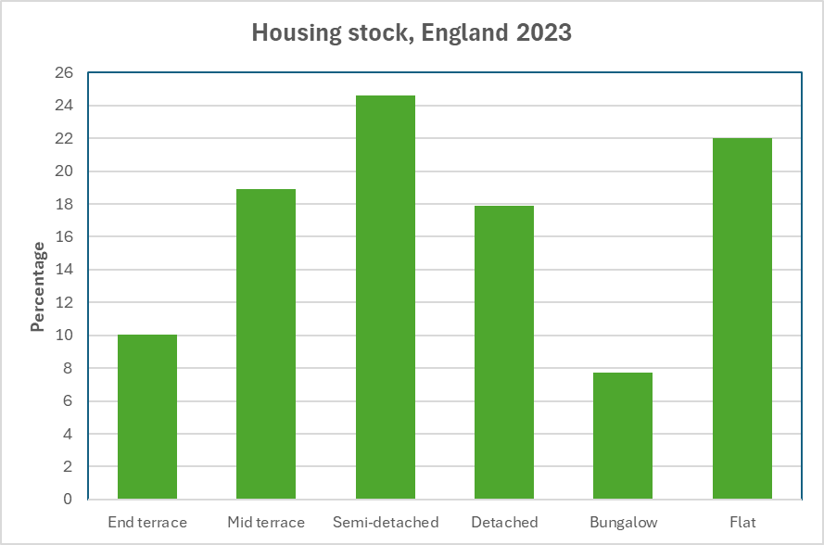
Figure 1: Dwelling archetypes

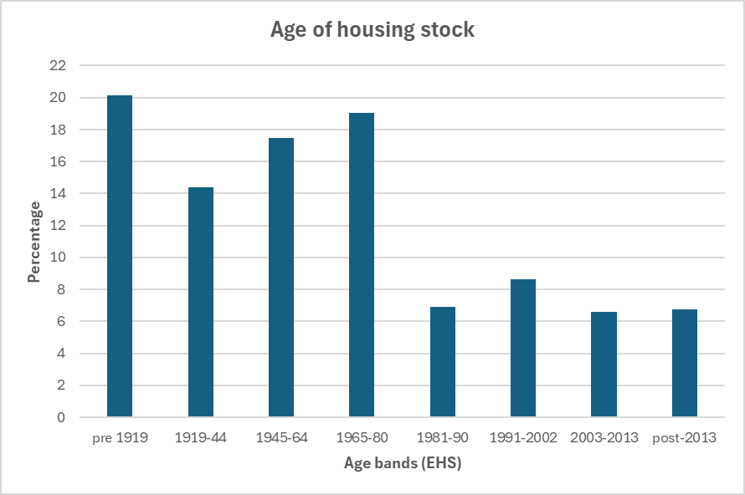
Figure 2: Age of housing

3. METHODOLOGY
The data and discussion in this paper are focussed on a specific dwelling archetype, bound by other constraints including building age and orientation to remain within scope for this publication. The context for this research is a much broader remit, looking at all UK dwelling archetypes in different locations, with additional variables included.
For this study, a mid-terrace dwelling situated in two locations, suburban and rural, with one orientation only (North-South) is used. A Dynamic Simulation Modelling (DSM) software programme, IESVE, is used to represent this archetype in a virtual environment, utilising the CIBSE climate weather files database. London Heathrow and London Gatwick are the default regions accessed for the simulations, representing suburban and rural environments respectively (definition and reference needed).
The climate data used are Test Reference Year (TRY) and Design Summer Year (DSY) files from the Chartered Institute of Building Services Engineers (CIBSE) based on UKCP09 [12].
Both TRY and DSY data includes climate projections for 2050 and 2080, with levels of probability measured at 10%, 50% and 90%. A base projection from 2020 is also used for this study. These data are based on the Intergovernmental Panel on Climate Change (IPCC) Representative Concentration Pathways Fifth Assessment Report [13].
Three dwelling age bands are used for the DSM projections: 1900-29; 1967-75; 2007-11. These are based on the Reduced data Standard Assessment Procedure for dwellings (RdSAP), bands, B, E and K [14].
Occupancy profiles are critical to this research, since they determine the length of time a space is occupied and therefore heating demand. Two occupancy profiles are used for the simulation models: ‘always on’ and ‘working couple with children’, derived from studies by Aragon [15] and Pullinger [16], as representative of the two most common work-life situations in the UK for occupants of a domestic dwelling.

3.1 The Mid-Terrace house
The age bands used for analysis of the mid-terrace dwellings are selected based on the number of properties built between 1900 and 1929 as noted in 2.3 above, and subsequently the two periods where national building regulations came into force (1967) and when requirements for thermal resistance were significantly upgraded (2006).
As an example of the difference in U-values between those three age bands, see Table 1.

Age band | External wall | U-value
B. 1900-29 | Solid Wall 280mm | 1.70
E. 1967-75 | Brick cavity 300mm 50 gap no insulation | 1.50
K. 2007-11 | Brick cavity 273mm 58mm EPS insulation | 0.30
Age band | Roof | U-value
B. 1900-29 | Pitched slate with battens no insulation | 2.30
E. 1967-75 | Pitched slate with battens 28mm insulation | 1.50
K. 2007-11 | Pitched slate 100mm EPS insulation | 0.20
Table 1: U-values by RdSAP age band

The U-values shown in Table 1 are derived from the RdSAP10 Specification of June 2025 [17]. RdSAP is the UK methodology for assessment of energy performance of existing buildings as approved by the Ministry of Housing, Communities and Local Government (MHCLG). There are several ISO standards relating to the calculation of thermal transmittance, depending on what components and materials are being considered. All of these are summarised in BR443, ‘Conventions for U-value calculations [18]. This document provides guidance on new buildings, noting that precise calculation of thermal resistance or transmittance in existing structures can be difficult:
“materials traditionally used in buildings may not be homogeneous and their thermal conductivity values may not be available… the exact composition and dimensions of layers of materials requires destructive methods” [19].
Given these constraints, the data tables of U-values provided in RdSAP10 are used for all dwelling model simulations in this research study. There is more discussion on the variation between DSM U-values and RdSAP in 3.5.
Thermal models for this study are derived from the literature e.g., [20, 21, 22] and measurement of dwellings from each period. An exemplar for the 1900 mid-terrace house is shown at Figure 3, with the actual 1907 property used as the basis for this at Figure 4.
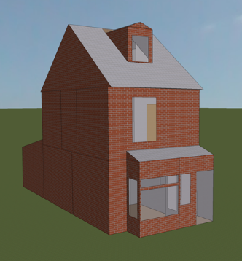  Figure 3: Mid-terrace model | 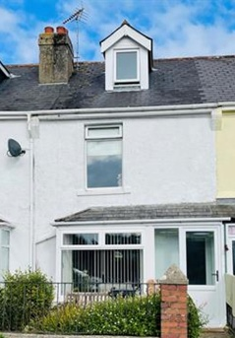  Figure 4: Actual house
Key differences in the dimensions, materials and components for dwellings in each age band include the size and height of windows (although not the type – 89% of all homes in England have double glazing) [23], the external wall composition, from solid wall to cavity, and necessarily due to Building Regulations, the level of insulation in walls and roof.

3.2 Occupancy profiles
Non-domestic buildings usually require some form of mechanical heating and cooling, the settings for which are usually determined by the heat balance scale of PMV-PPD [24]. Very few domestic dwellings in England rely on anything other than natural ventilation, with indoor comfort levels based on external temperatures. This forms the basis for the adaptive comfort model [25] as developed by Humphreys and Nicol.
The importance of adaptive comfort as a measure of satisfaction with internal environments has increased in the 21st century, with awareness of both overheating in warmer summers, and fuel poverty [26] for people dealing with increased energy costs in the 2020s.
The two occupancy profiles used have distinct patterns: ‘always on’ or ‘Full’ has a morning and evening energy use peak, but is less pronounced than the ‘working couple’ peak, where typically the amount of energy used is very high relative to daytime hours, where it can be zero or nearly so, dependent on season.
The ‘always on’ profile refers to both retired persons not following a daily commuting pattern to a workplace, and people working from home on a remote basis, much more commonplace since the Covid pandemic of 2020-2022 [27]. The ‘working couple with children’ profile is used as proxy for all persons commuting to a place of work and doing a daily ‘school run’.

3.3 Regulations and standards for heat and cold
There is a traceable lineage for current UK legislation and standards applicable to internal building environments. The Building Regulations Part ‘O’, Overheating, is based on the CIBSE Technical Memoranda TM52 and TM59 [28, 29, 30], which draw on various British Standards including BS EN 15251:2007 concerning indoor environmental parameters and thermal comfort [31]. These reference texts use research carried out in the 1960s and onwards, both for mechanical heating and ventilation via Fanger and the PMV/PPD heat balance methodology and Humphreys and Nicol with their studies into adaptive comfort. Note that all UK standards in this subject area are related to the requirements of the European Energy Performance of Buildings Directive (EPBD) Directive (EU) 2024/1275 [32].
The two CIBSE technical documents serve different purposes: TM59 is designed for new-build or renovated homes, apartments, and student accommodation, while TM52 is primarily for office buildings, commercial projects, or to assess spaces used primarily during the day. Both TM52 and TM59 are pivotal to the methods used in this study, since they provide guidance that is used as standard in other research and is now incorporated into standards and regulations. One example of this is the use of DSY1 weather files for overheating analysis, as recommended in Section 3.2 of TM59 [33].

3.4 Adaptive comfort and weighted exceedance
The comfort standard that sets out the PMV/PPD method of thermal sensation for buildings using mechanical ventilation is BS EN ISO 7730:2025 [34] (although other building environments can be used with this). The thermal comfort scale is based on Fanger’s 1970s study, as shown in the Standard:

+ 3 | Hot
+ 2 | Warm
+ 1 | Slightly warm
0 | Neutral
- 1 | Slightly cool
- 2 | Cool
- 3 | Cold
Table 2: PMV/PPD thermal comfort scale BS 15251

There are several issues when applying this method to calculate thermal comfort in naturally ventilated buildings: the ability of occupants to adapt to internal environments by e.g., opening windows, adjusting clothing, changing the level of activity, and also the capacity to adjust their metabolic expectations based on outdoor conditions. One of the main outcomes from studies by Humphreys and Nicol show that people expect and tolerate greater temperature fluctuations than those in controlled environments. When applying the PMV/PPD formula to naturally ventilated spaces, the model overestimates occupant dissatisfaction, wrongly predicting discomfort two out of three times [35].
There are three factors to consider when evaluating spaces in a naturally ventilated domestic dwelling for thermal comfort: the comfort temperature; building category with associated comfort temperature range; and criteria for defining overheating in that space.
From BS EN 15251:2007, as shown in TM52, the formula that relates indoor comfort temperature to outdoor temperature uses a specific measure for outdoor air temperature.
This is an exponentially weighted running mean of the daily mean outdoor air temperature; a calculation that tracks the average of a data series over time, but decreasing the weighting of those data so that recent data – in this case temperature in the past few days - has more impact. The formula is:

$$T_{comf} = 0.33 T_{rm} + 18.8$$

where T_{comf} is the comfort temperature, T_{rm} is the exponentially weighted running mean temperature. For example, if T_{rm} is 10°C, T_{comf} will be 22.1°C, as follows:

$$10 x 0.33 = 3.3 + 18.8 = 21.1°C$$

The second factor when evaluating thermal comfort is how buildings and their indoor environments are categorised. BS EN 15251 sets out a method for these, with acceptable temperature ranges.

Category | Explanation | Suggested acceptable range (K)
I | High level of expectation only used for spaces occupied by very sensitive and fragile persons | ± 2
II | Normal expectation (for new buildings and renovations) | ± 3
III | A moderate expectation (used for existing buildings) | ± 4
IV | Values outside the criteria for the above categories (only acceptable for limited periods) | > 4
Table 3: Indoor environment categories and acceptable temperature ranges for naturally ventilated buildings BS 15251

The third factor is the overheating criteria: TM52 sets out three conditions, from which any space or building that fails two of the three is considered to be overheating. The full description is found in 6.1.2 of the guidance, but in brief:
Criterion 1 sets a limit on hours of exceedance (of the comfort temperature): how many hours the operative temperature can exceed the upper limit of the comfort temperature range by 1 K or more during the non-heating season.
Criterion 2 sets a daily weighted exceedance for acceptable overheating, which monitors the change in temperature at timed intervals during a given day.
Criterion 3 sets an absolute maximum value for indoor operative temperature, where the change in temperature ΔT must not exceed 4 K.
For this study: Category III (moderate expectation of comfort in existing buildings) is used, with a temperature range of ± 4°C. Criterion 1 is the metric used in the data export from the simulation models, number of degrees greater than the maximum adaptive temperature.

3.5 Dynamic Simulation Models
The software used to generate the virtual models is IESVE [36], one of three software programs using dynamic simulation modelling validated by the UK Government for use in calculating energy performance of buildings [37]. While IESVE is approved for non-domestic buildings under the National Calculation Methodology (NCM) [38], the standards and methods used are suited to the modelling of domestic buildings also. The input variables available in IESVE provide for both individual housing archetypes and entire streetscapes to be modelled, using climate files from CIBSE to specify a UK location. Two of these locations are recognised as default for urban and rural weather models, London Heathrow and London Gatwick [39]. The variation between urban and rural climate in terms of dwelling simulations relates to the Urban Heat Island (UHI) effect: temperatures rise with proximity to a city centre. For reference, London Weather Centre (LWC) is the third CIBSE weather file available, used to represent inner-city conditions, but not used in this study.
All variations of the mid-terrace models were simulated in a streetscape environment, with each measured dwelling in the middle of a terrace of identical properties facing directly south to the front (on to the street), with tree cover at the rear between the adjoining streets, per Figure 5. The methodology here mirrors the work of Gupta and Gregg [40], to allow for both shading and solar reflectance off nearby surfaces.
For the Mid-terrace dwelling, 96 simulations were run in each age band, representing 48 per each occupancy profile, 12 for each orientation in urban and rural locations, 288 total. Climate weather files from CIBSE, corresponding to three emissions scenarios under Representative Concentration Pathways (RCP) as specified by the Met Office UK Climate Projections (UKCP18) [41] are used for the simulations. These pathways are defined by the level of temperature change projected for future time periods in the 21st century. Per Table 4 below, the ‘High’ emissions scenario equates to RCP8.5, a temperature increase within the range of 3.2°C to 5.4°C between 2081 and 2100. The ‘Medium’ scenario is closest to RCP6.0, with a temperature range of 2.0°C to 3.7°C. A ‘Low’ option is RCP4.5, 1.7°C to 3.2°C.
Each emissions scenario uses the 50% probability level, meaning an outcome for each scenario that has a 50/50 chance of being exceeded. While previous studies vary between the 50% and 90% levels, the consensus appears to be the median probability [40, 42]. The Medium probability column in Table 4 is highlighted to emphasise the default scenario used in this paper, per the detail in Section 4, Results.
Two types of climate projection file are used: Design Summer Year (DSY1) and Test Reference Year (TRY). DSY1 represents a long warm summer rather than a series of shorter more extreme temperature events, generated from specific historical years, while the TRY is a ‘typical’ weather year generated from a thirty-year period of temperature data [43].
DSY1 data are used for the ‘too hot’ scenarios, with the TRY data enabled for ‘too cold’ projections.

Figure 5: Sample DSM Streetscape Mid-Terrace 1900-29 North-South orientation
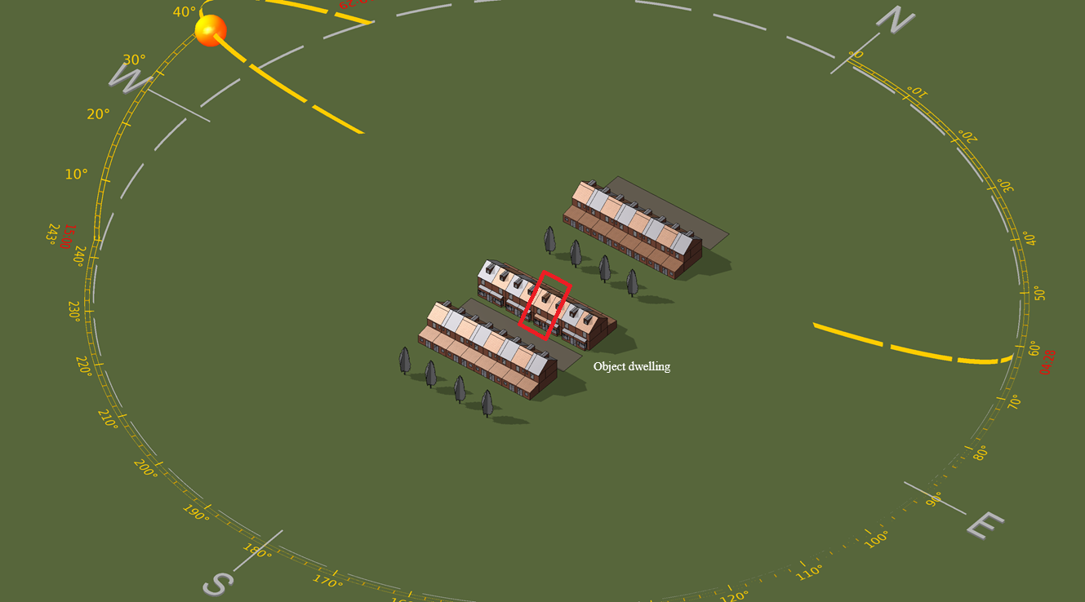
Dwelling archetype = Mid-terrace
Age band | Profile | Room | Orientation | Location | Climate  file | Year | Probability
1900-29 “As-built” | Full and Work Occupancy | Living Room | N-S | Urban and Rural | DSY1 | 2080 | High  50% | Medium  50% | Low  50%
1967-75 “Building Regs” | Full and Work Occupancy | Living Room | N-S | Urban and Rural | DSY1 | 2050 | High  50% | Medium  50%
2007-11 “Part L1B” | Full and Work Occupancy | Living Room | N-S | Urban and Rural | DSY1 | 2020 | High  50%
 |  |  |  | Urban only | TRY | 2080 | High  50% | Medium  50% | Low  50%
 |  |  |  | Urban only | TRY | 2050 | High  50% | Medium  50%
 |  |  |  | Urban only | TRY | 2020 | High  50%

Table 4: Dynamic Simulation Models

A brief summary of the process used to produce the data follows:
Three models of a Mid-Terrace dwelling were created in IESVE, representing the three age bands used for this study (1900-29, 1967-75, 2007-11). Appropriate materials and dimensions from the literature were input [44, 45] to the software constructions database, to ensure valid U-values for each component i.e., walls, floors, roofs, windows. With regard to overheating and occupant comfort, there are three elements to account for: heating, occupancy and window opening schedules. Profiles for each of these were added to every dwelling model.
Data from each simulation were extracted using four metrics, all in degrees Celsius: operative temperature, degrees greater than maximum adaptive temperature, daily running mean temperature and dry-bulb temperature.
Each metric provides an hourly entry for every day of the year, hence 8,760 data points per metric within each simulation. From the data, a percentage is derived from the number of degree hours where the Living Room in the Mid-Terrace dwelling is too hot or too cold under a given climate scenario for 2020, 2050 and 2080, using specific sensitivities as detailed in Section 4.
A sample of the data export from IESVE is presented in Figure 6, including a formula to determine if the space is occupied at any point in the time series. The occupancy schedules for the Living Room are derived from TM52, with Full occupancy being 07:00 to 23:00 Monday to Sunday, and Work Occupancy 07:00 to 09:00, then 16:00 to 23:00 Monday to Friday. In both cases Full Occupancy applies to the weekend Saturday and Sunday, while the space is unoccupied under both profiles from 23:00 to 07:00.
The heating / non-heating season profiles also follow TM52 guidance, where the heating for each model is turned off between 1st May and 30th September.
For the window-opening schedules, the studies undertaken by Humphreys, Nicol and Rijal informed the profile schedules [46], since their research underpins CIBSE Guide A and TM52/TM59. Two numbers are key to the modulating profiles: windows open when the internal dry bulb temperature exceeds 22°C, and per Rijal, “the adaptive approach suggests that the use of controls is triggered by the discomfort of the user” [47] a ‘deadband’ range of 4 K, i.e., ± 2°C is used. This allows for a period of time where the models simulate the gradual opening and closing of windows between 20°C and 24°C, rather than an open/closed setting at the same temperature.

Figure 6: Dynamic Simulation Models data export sample

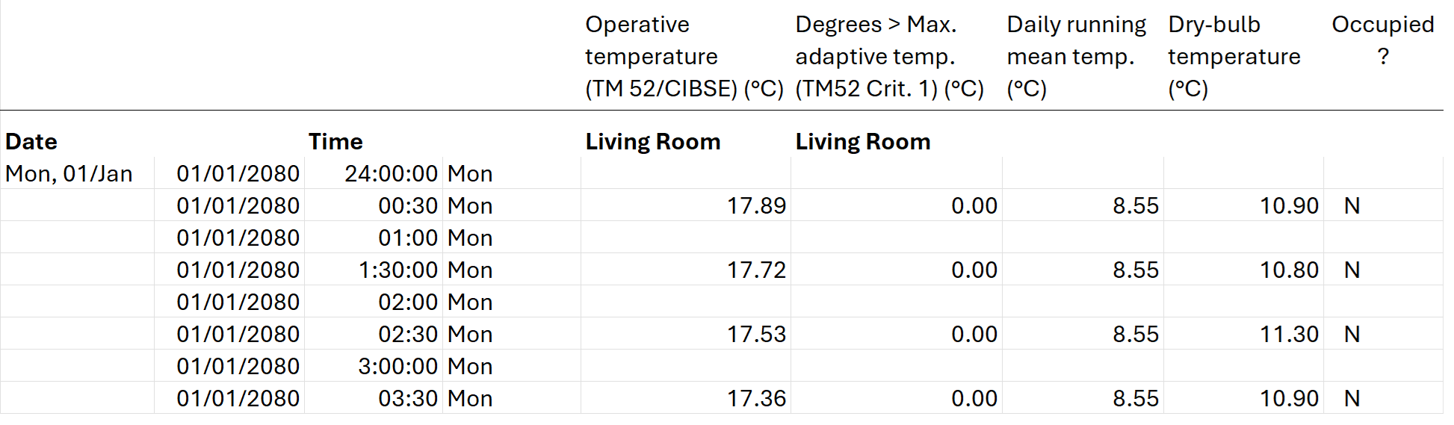

4. RESULTS AND DISCUSSION
From the data export for each model, specific calculations from the time-series temperatures were extracted and compared across age bands, emissions scenarios, location and orientation.
Figures 7 to 10 inclusive show data for annual degree hours expressed as a percentage of the total, where the Living Room (when occupied) operative temperature exceeds $T_{comf}$ the adaptive comfort temperature by 4°C, under the acceptable range for Category III existing buildings.
Each Figure details the breakdown for a mid-terrace dwelling in three age bands, using the RCP 6.0 Medium Emissions scenario at 50% probability as the baseline for 2080, 2050 and 2020. The error bars in each column define the range from low-to-high emissions (RCP4.5 to RCP8.5) to which the RCP 6.0 Medium Emissions scenario at 50% probability could vary, depending on the rise in temperature and concentrations in greenhouse gases relative to pre-industrial levels, over the next several decades.
As stated in Section 3, the scenarios used here are based on the IPCC Fifth Assessment Report: note that the Sixth report [48] introduced Shared Socio-Economic Pathways (SSP’s) over RCPs, and more recent research has determined that the High Emissions RCP8.5 scenario will be retired, with a new schema proposed for all scenarios [49.]
The orientation for all dwellings used as models in this paper is North-South, with the Living Room facing due South. The two occupancy profiles are included, broken down by urban and rural locations.
The data in Figures 7 through 10 are presented in graphic form, for a mid-terrace dwelling in an urban area with full occupancy, rural area full occupancy, urban area work occupancy, and rural area work occupancy respectively.
Figure 11 is included as a comparator to the percentage of degree hours too hot, given that part of any year in the UK can still be colder than the average. This data is drawn from the same model simulations, using the same temperature calculation in reverse, so to speak. This takes annual degree hours as a percentage where the operative temperature is 4°C less than the adaptive comfort temperature.

4.1 Summary of the results
A clear pattern is seen across all the ‘Percentage too hot’ figures: the more recent the dwelling construction, the greater the number of degree hours above the adaptive comfort temperature range.
This is especially so for dwellings built according to the requirements of the 2006 Part L Building Regulations, specifying lower U-values, reduction of air leakage and greater levels of insulation. The comparison between the change in overheating percentage from the 2006 and later properties to those first built after the 1965 national building regulations came into effect is significant – the initial requirements for insulation were very basic [50] and rarely enforced.
There is also a difference in overheating based on occupancy profiles: the percentage of degree hours too hot for dwellings with full occupancy is about double that for the working profile. The ‘full’ profile shows a range of ~20% to 22% for post-2006 dwellings, while the ‘work’ profile is ~9% to 11%. The rural location has similar results, but consistently 1pp to 2pp less.
In all cases, the dwellings modelled on construction methods and materials used in the earlier age bands 1900-29 and 1967-75 show significantly fewer degree hours of overheating under any of the emissions scenarios, with a margin of error proportionate to the total.
The counterpart to a model of overheating is the possibility of a dwelling being too cold. Using TRY weather data for the same set of dwelling models, the results in Figure 11 present a consistent dataset where the mid-terrace dwelling for the future climate periods is too cold for 0.7% to 3.1% of degree hours measured below the adaptive comfort temperature. The exception is the 1900-29 dwelling under the 2020 data simulation.
There is a specific limitation for all data shown here under the 2020 baseline, in that only High Emissions scenario climate files are available. Hence the asterisk against all graphic columns for 2020. Since this date is in the past, the figure can only be interpreted as a guide to future heating and cooling. For reference, the percentage shown against the 1900-29 model at year 2020 in Figure 11 is 1.6%; this represents 25.05 degree hours for the year.
The higher percentages shown for the work occupancy profile relative to full, makes sense from the perspective of more heating transitions with the movement of people entering and leaving the property over the course of a working week, during any twelve moth period. Hence being “too cold” is not an extended period of time, rather the interim as people ‘re-occupy’ the property.

4.2 Constraints
The fundamental limitation of all virtual environments is the maxim first quoted by George Box “All models are wrong, but some are more useful than others” [51]. A study in 2011 on DSM software packages established that simulation results within 10 – 15% of actual building performance were as close as any virtual model can achieve. The challenge is to validate the results against established values from the literature across all required metrics.
A further consideration is the local environment for each dwelling. After some experimentation using a single house model, the results showed a clear difference in solar gain and energy use when placing the object dwelling with a streetscape. The other properties within the model file are set as void spaces, to ensure all data are generated by the object dwelling only.
Per the initial discussion on climate scenarios, an updated set of climate weather files from CIBSE via the Met Office and the Universities of Exeter and Loughborough are now available [52]. These provide more locations and more granular climate date than previously, using UKCP18 projections. The next round of dwelling simulations in the research related to this paper will use the new climate data.

5. CONCLUSION
Per the introduction to this paper, the aim is to develop methods using DSM that enable resources to be allocated to dwellings in the UK most in need of adapting for a warming climate. The research so far demonstrates how these methods may be developed, but requires both a greater number of simulation models under different UK climate regions, and the testing of specific adaptations for each dwelling archetype to find the most efficient.
The results presented in this paper are derived from a study limited to one dwelling archetype with specific sensitivities input for the dynamic simulation models. A much broader remit for this research, using all UK dwelling archetypes and different climate regions continues as part of the study.

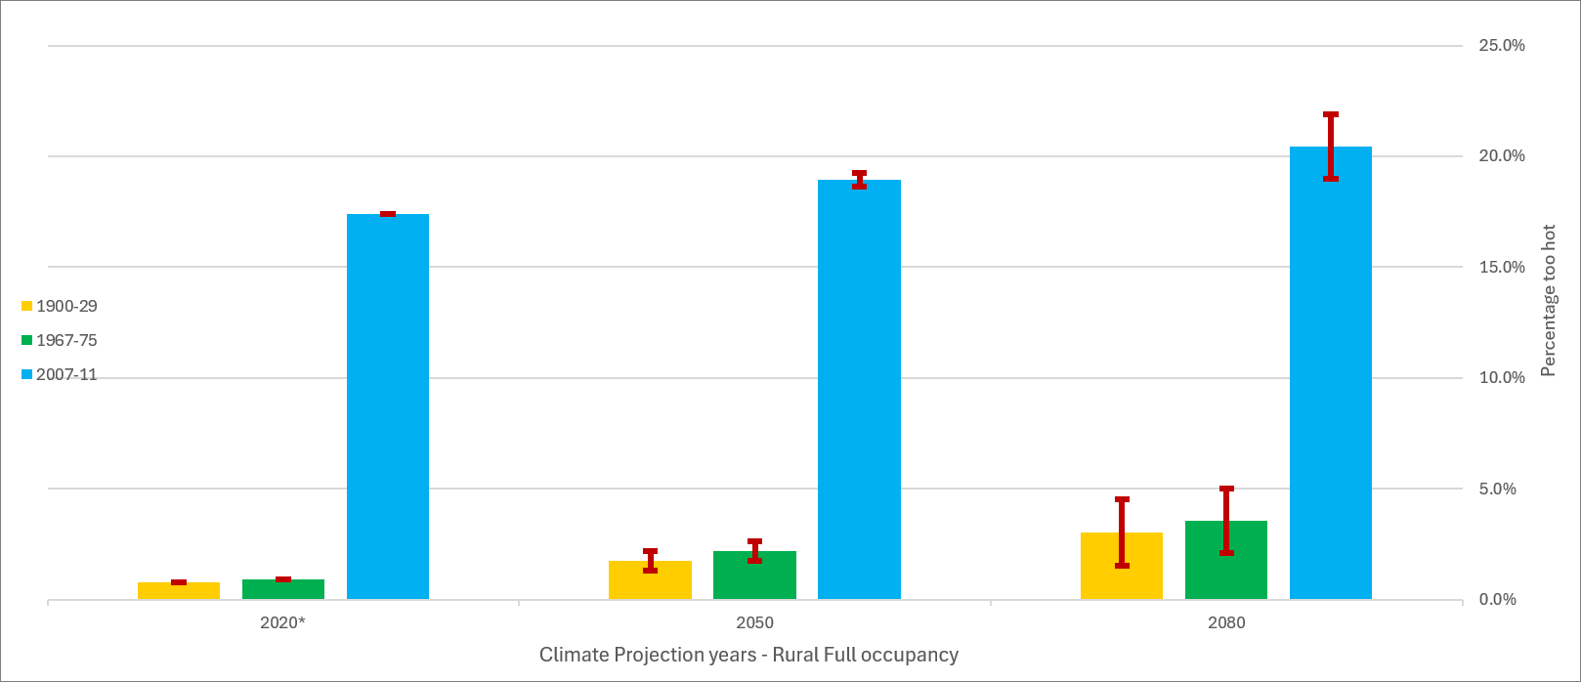
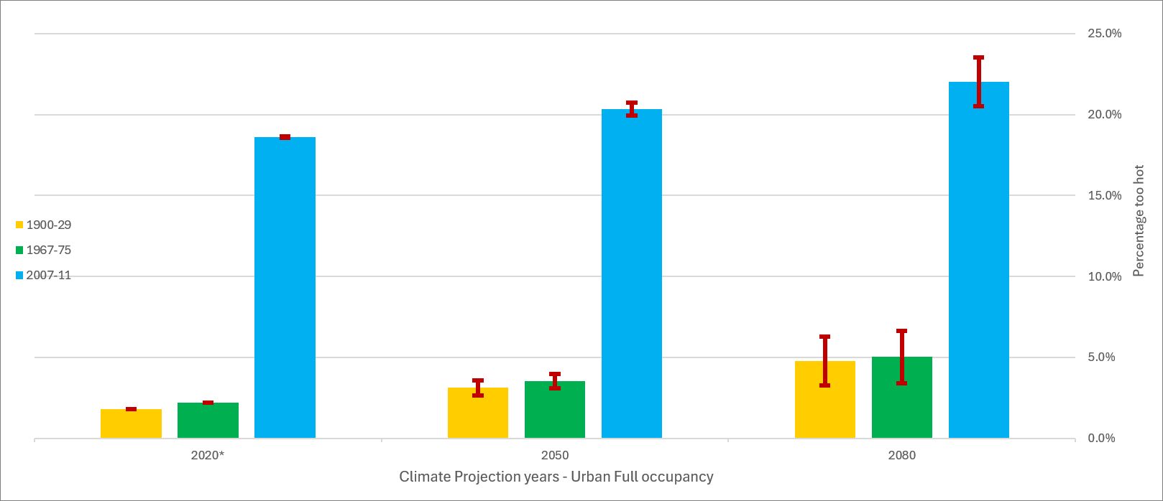
Figure 8: Mid-Terrace Rural area Full Occupancy, three age bands, Percentage Too hot
Figure 7: Mid-Terrace Urban area Full Occupancy, three age bands, Percentage Too hot
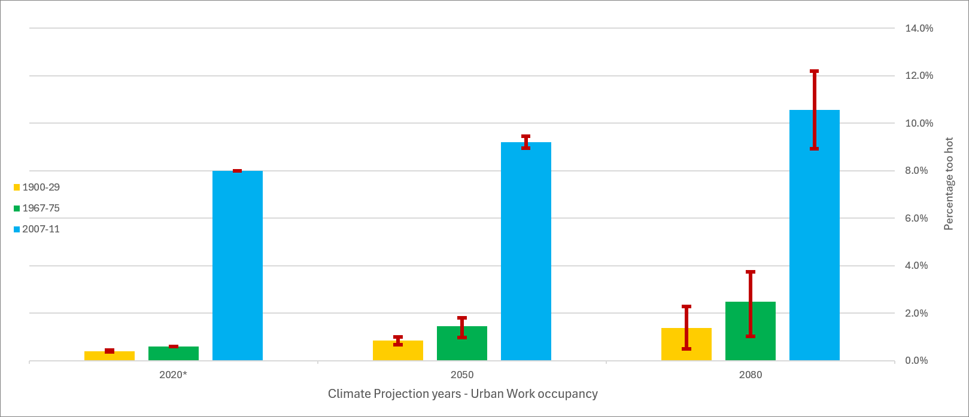
Figure 9: Mid-Terrace Urban area Work Occupancy, three age bands, Percentage Too hot

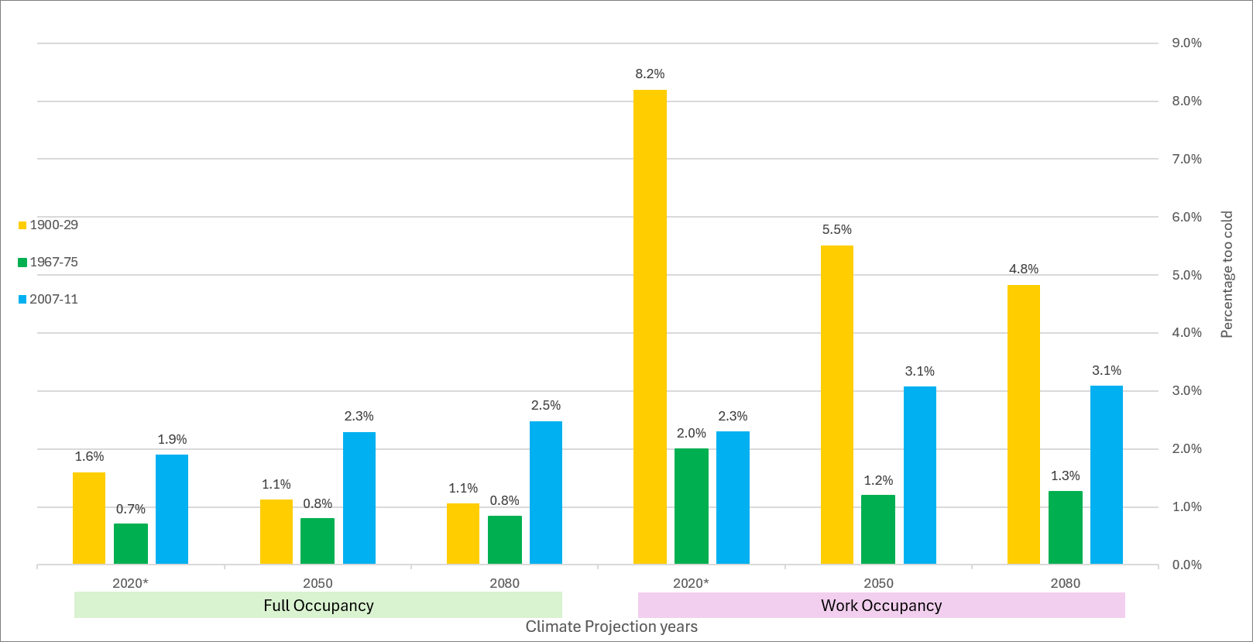
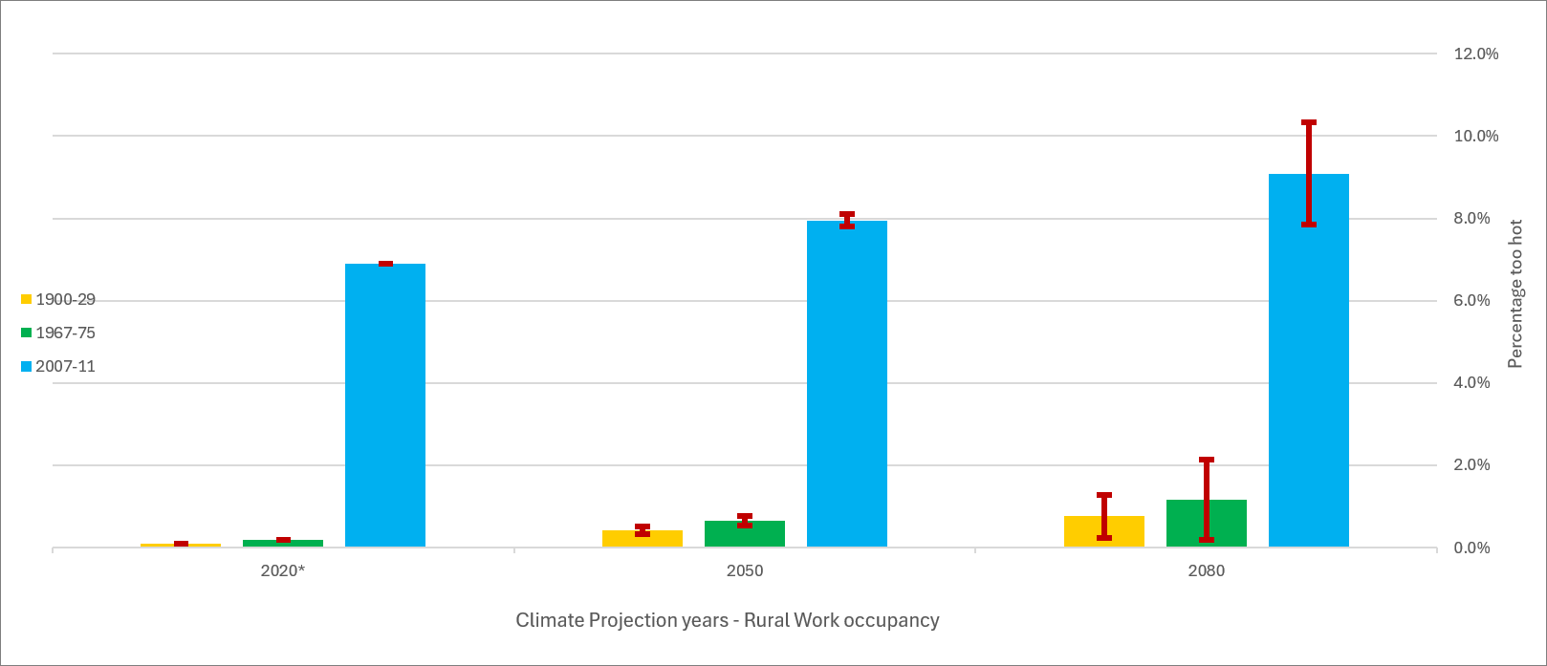
Figure 11: Mid-Terrace Urban area Full and Work Occupancy, three age bands, Percentage Too cold
Figure 10: Mid-Terrace Rural area Work Occupancy, three age bands, Percentage Too hot

There are some clear trends shown in the data: the post-2006 dwellings will overheat to a much greater extent in mid-21st century than those built in earlier decades. For anyone looking to buy a mid-terrace house built in the 1960s onward, there are some choices to be made depending on the level of insulation present – weather-proofing rather than over-insulating may be a better investment.
Another trend to consider as this research progresses is the cost and benefit of a property that gets too hot when people are working from home full time. There is a body of research already on the health effects of overheating on vulnerable people – those in a Category I building space – but the data shown here for recent builds portends a greater issue in a warming climate.
Continuing the theme from Section 4, the data can only show a reasonable representation of reality, given the constraints of both virtual and real built environments, including occupant behaviours. While there is no single depiction of a UK domestic dwelling that can capture all the complexities and variations possible, virtual models based on a broad spectrum of existing research can assist with policy in terms of spending taxpayer funds to make homes more resilient to climate change.
The potential significance of this study to passive and low energy architecture is the recognition that a warming climate may be beneficial to occupants in terms of adaptive comfort, refurbishing only those dwellings that require adaptation, and leaving alone those that will cope well enough with a warming climate. The use of DSM to replicate homes in their local environments, incorporating the PLEA ‘common sense architecture’ pillar of local wisdom to only change and adapt where necessary, is the basis of this research.

ACKNOWLEDGEMENTS
This paper is part of a doctoral study by the lead author at the University of Portsmouth. The same author works full-time as a Senior Lecturer at the University of the Built Environment, Reading, UK, without whose sponsorship this research would not be possible.

REFERENCES
1. Committee on Climate Change, [Online], UK housing: Fit for the future? Available: https://www.theccc.org.uk/ publication/uk-housing-fit-for-the-future/ [21 February 2019].
2. Integrated Environmental Solutions Limited(a), [Online], Available: https://iesve.com/ [2 January 2026].
3. BRE, (2025a). RdSAP10 Specification V3.0, Building Research Establishment.
4. EHS, (2024a). English Housing Survey, Housing Stock Dataset. MHCLG, English Housing Survey.
5. Lomas, K. and Porritt, S., (2017). Overheating in buildings: lessons from research. Building Research & Information, 45(1-2): p. 1-18.
6. De Dear, R., Xiong, J., Kim, J. and Cao, B., (2020). A review of adaptive thermal comfort since 1998. Energy & Buildings, 214: p. 109893.
7. Gupta, R. and Gregg, M., (2016). Do deep low carbon retrofits actually work? Energy and Buildings, 129: p. 330-343.
8. Glew, D., Smith, M., Miles-Shenton, D. and Gorse, C., (2017). Assessing the quality of retrofits in solid wall dwellings. International Journal of Building Pathology and Adaptation. 35(5): p. 501–518.
9. CITB [Online], Construction Workforce Outlook 2025-2029. Construction Industry Training Board. Available: https://www.citb.co.uk/cwo/ [10 January 2026].
10. Murray, A. (2025). Business Statistics. Research Briefing Number CBP 06152, House of Commons Library.
11. EHS, (2024b). English Housing Survey, Headline Report Chapter 1, profile of Households and dwellings, Annex Tables. MHCLG.
12. CIBSE [Online], Chartered Institution of Building Services Engineers. Weather Data. Available: https://www.cibse.org/weatherdata/ [15 May 2026].
13. IPCC, (2014). Climate Change 2014: Synthesis Report. Contribution of Working Groups I, II and III to the Fifth Assessment Report of the Intergovernmental Panel on Climate Change. Eds: Pachauri, R. and Mayer, L. IPCC, Geneva, Switzerland.
14. BRE, (2025b). RdSAP10 Specification V3.0, Table 1, Building Research Establishment.
15. Aragon, V., Gauthier, S., Warren, P., James, P. and
Anderson, B. (2019). Developing English domestic occupancy profiles. Building Research & Information, 47(4): p. 375-393.
16. Pullinger, M., Zapata-Webborn, E., Kilgour, J., Elam, S., Few, J., Goddard, N., Hanmer, C., McKenna, E., Oreszczyn, T., Webb, L. (2024). Capturing variation in daily energy demand profiles over time with cluster analysis in British homes (September 2019 – August 2022). Applied Energy, 360: p. 122683.
17. BRE, (2025c). RdSAP10 Specification V3.0, Tables 6 and 18, Building Research Establishment.
18. Anderson, B. and Kosmina, L. (2019a). Conventions for U-Value calculations 3rd Ed. BR443, Building Research Establishment.
19. Anderson, B. and Kosmina, L. (2019b). Conventions for U-Value calculations 3rd Ed., p.7. BR443, Building Research Establishment.
20. Tudor Walters, J., (1918). Report of the Committee appointed by the President of the Local Government Board...to consider the Provision of Dwellings for the Working Class... Cd. 9191. London, HMSO
21. Central Housing Advisory Committee, (1944). Design of dwellings: Report of the Design of dwellings subcommittee of the Central housing advisory committee, also known as the ‘Dudley Report’. London, HMSO.
22. Ministry of Health, (1949). Housing Manual 1949. London, HMSO.
23. EHS, (2024c). English Housing Survey, Headline Report 2024-25: housing quality and energy efficiency. MHCLG, English Housing Survey.
24. Fanger, P., (1970). Thermal comfort: analysis and applications in environmental engineering. Copenhagen, Krieger.
25. Humphreys, M. and Nicol, F. (1998). Understanding the adaptive approach to thermal comfort. ASHRAE Transactions 104(1): p. 991–1004.
26. Parliament. House of Commons (2024). Fuel Poverty Awareness Day. Early Day Motions EDM 467: tabled 26 November 2024. London: House of Commons.
27. Office for National Statistics (ONS) [Online], Dataset, Public opinions and social trends, Great Britain: working arrangements. Release date 15 May 2026. Available:
https://www.ons.gov.uk/peoplepopulationandcommunity/wellbeing/datasets/publicopinionsandsocialtrendsgreatbritainworkingarrangements
28. Ministry of Communities, Housing and Local Government (MHCLG), [Online], Building Regulations Part O. Available: https://www.gov.uk/government/publications/overheating-approved-document-o/ [8 January 2026].
29. CIBSE, (2013). The limits of thermal comfort: avoiding overheating in European buildings. Chartered Institution of Building Services Engineers, Technical Memorandum TM52: 2013.
30. CIBSE, (2017a). Design methodology for the assessment of overheating risk in homes. Chartered Institution of Building Services Engineers, Technical Memorandum TM59: 2017.
31. British Standards Institution (2007). BS EN 15251: 2007 Indoor environmental input parameters for design and assessment of energy performance of buildings addressing indoor air quality, thermal environment, lighting and acoustics. London: British Standards Institution.
32. European Union, [Online]. Directive (EU) 2024/1275 of the European Parliament and of the Council of 24 April 2024 on the energy performance of buildings. Available: https://eur-lex.europa.eu/legal-content/EN/TXT/? uri=CELEX%3A02024L1275-20260524 [30 May 2026].
33. CIBSE, (2017b). Design methodology for the assessment of overheating risk in homes. Chartered Institution of Building Services Engineers, Technical Memorandum TM59: 2017 p.3
34. British Standards Institution (2025). BS EN ISO 7730:2025 Ergonomics of the thermal environment — Analytical determination and interpretation of thermal comfort using calculation of the PMV and PPD indices and local thermal comfort criteria. London: British Standards Institution.
35. Cheung, T., Schiavon, S., Parkinson, T., Peixian Li, Brager, G. (2019). Analysis of the accuracy on PMV – PPD model using the ASHRAE Global Thermal Comfort Database II. Building and Environment, 153: p. 205-217.
36. Integrated Environmental Solutions Limited(b), [Online], Available: https://iesve.com/ [2 January 2026].
37. Ministry of Communities, Housing and Local Government (MHCLG), [Online], Approved software for the production of non-domestic Energy Performance Certificates. Available: https://www.gov.uk/government/publications/department-for-communities-and-local-government-approved-software-for-the-production-of-non-domestic-energy-performance-certificates-epc. [10 January 2026].
38. National Calculation Methodology (NCM), [Online], UK's National Calculation Method for Non Domestic Buildings. Available: https://www.uk-ncm.org.uk/index.jsp
39. CIBSE, (2014a). Design Summer Years for London. Chartered Institution of Building Services Engineers, Technical Memorandum TM49: 2014.
40. Gupta, R. and Gregg, M., (2013) Preventing the overheating of English suburban homes in a warming climate. Building Research & Information 41(3): p. 281-300.
41. Fung, F. and Gawith, M. (2018). UKCP18 for UKCP09 Users, UKCP18 Guidance. Met Office Hadley Centre, Exeter.
42. Viganò, G., Rugani, R., Marengo, M., Picco, M. (2024). Assessing the Impact of Climate Change on Building Energy Performance: A Future-Oriented Analysis on the UK. Architecture 4: p. 1201–1224.
43. CIBSE, (2014b). Design Summer Years for London. Chartered Institution of Building Services Engineers, Technical Memorandum TM49: 2014.
44. Muthesius, S. (1982). The English Terraced House.
New Haven and London, Yale University Press.
45. Neufert, E. (2023). Architects’ Data 6th Ed. Translated by Sturge, D. and Luhman, N. Chichester, Wiley Blackwell.
46. Rijal, H., Tuohy, P., Nicol, F., Humphreys, M., Samuel, A. and Clarke, J. (2007). Development of an adaptive window opening algorithm to predict the thermal comfort, energy use and over heating in buildings. Journal of Building Performance Simulation 1(1): p. 17–30.
47. Rijal, H., Tuohy, P., Humphreys, M., Nicol, F., Samuel, A. and Clarke, J. (2007). Using results from field surveys to predict the effect of open windows on thermal comfort and energy use in buildings. Energy and Buildings 39(7): p. 823–836.
48. IPCC, (2023). Climate Change 2023: Synthesis Report. Contribution of Working Groups I, II and III to the Sixth Assessment Report of the Intergovernmental Panel on Climate Change. [Core Writing Team, H. Lee and J. Romero (eds.)]. IPCC, Geneva, Switzerland, p. 35-115.
49. Van Vuuren, D. plus 44 authors (2026). The Scenario Model Intercomparison Project for CMIP7 (ScenarioMIP-CMIP7). Geosci. Model Dev., (19), p. 2627–2656.
50. The Building Regulations 1965 (SI 1965/1373), [Online]. Available: https://legislation.gov.uk [4 May 2026].
51. Box, G. and Draper, N. (1987). Empirical model-building and response surfaces. Chichester, John Wiley & Sons p. 424.
52. CIBSE [Online], Chartered Institution of Building Services Engineers. Technical Briefing, CIBSE Weather Data (2025 Release) V1.1. Available: https://www.cibse.org/weatherdata/ [20 May 2026].

